**PREDICTIVE WORKFORCE PLANNING AND**

**OPTIMIZATION**

*A project report submitted to ICT Academy of Kerala*

*in partial fulfillment of the requirements*

*for the certification of*

**CERTIFIED SPECIALIST**

**IN**

**DATA SCIENCE & ANALYTICS**

submitted by

**Team : 5**

**Members : ASWIN PRABHAKARAN, ALEN SEBASTIAN, ANURAG N, AMBADI B KURUP**

**Name : HUDA VS**



**ICT ACADEMY OF KERALA**

**THIRUVANANTHAPURAM, KERALA, INDIA**

**Nov 2022**

**List of Figures**

|  |  |  |
| --- | --- | --- |
| **Figure Number** | **Figure Title** | **Page Number** |
| fig 1 | Flow of project | 13 |

|  |  |
| --- | --- |
| **Abbreviation** | **Full Term** |
| css | cascading style sheets |
| HTML | Hyper text markup language |
| numpy | numerical python |

**List of Abbreviations**

**Table of Contents**

Abstract……………………………………..6

**1.Problem definition**……………………………………………………………………….. 8

**2.Introduction**……………………………………………………………………………....9

**3.LiteratureSurvey**……………………………………………………………………10

4.**Methodology**………………………………………………………………………..13

           4.1 Flow of project…………………………………………………………………………13

           4.2 language and platform used…………………………………………………………….13

[Key Features 1](https://docs.google.com/document/d/1I7WitThD2jKsRzSuMlw3HQ6Cp5UTqurfcx-hl3HRIvw/edit#heading=h.o6tzx5mskepl)4

[Applications 1](https://docs.google.com/document/d/1I7WitThD2jKsRzSuMlw3HQ6Cp5UTqurfcx-hl3HRIvw/edit#heading=h.bgdhlf94ywk6)4

[Python in Data Science 1](https://docs.google.com/document/d/1I7WitThD2jKsRzSuMlw3HQ6Cp5UTqurfcx-hl3HRIvw/edit#heading=h.n75ws5q1zky7)4

[Integration with Flask: 16](https://docs.google.com/document/d/1I7WitThD2jKsRzSuMlw3HQ6Cp5UTqurfcx-hl3HRIvw/edit#heading=h.cfxfoxtobcht)

[Integration with Python Data Science Libraries: 1](https://docs.google.com/document/d/1I7WitThD2jKsRzSuMlw3HQ6Cp5UTqurfcx-hl3HRIvw/edit#heading=h.t8nbu5ph92jo)7

[Key Features of Flask: 1](https://docs.google.com/document/d/1I7WitThD2jKsRzSuMlw3HQ6Cp5UTqurfcx-hl3HRIvw/edit#heading=h.3s0uoqre8feh)7

5.Implementation………………………………………………………………………………………..20

           5.1 Gathering requirements and defining problem statement……………………………..20

           5.2 Data collecting and importing……………………………………………………………..20

[5.3     Data Pre-processing 2](https://docs.google.com/document/d/1I7WitThD2jKsRzSuMlw3HQ6Cp5UTqurfcx-hl3HRIvw/edit#heading=h.olyqcp7wyudi)1

[5.3.1  Dealing with Missing values](https://docs.google.com/document/d/1I7WitThD2jKsRzSuMlw3HQ6Cp5UTqurfcx-hl3HRIvw/edit#heading=h.cb6x23qu1740) 22

[5.3.2  Outlier correction](https://docs.google.com/document/d/1I7WitThD2jKsRzSuMlw3HQ6Cp5UTqurfcx-hl3HRIvw/edit#heading=h.beey73vlkz1o) 24

[5.4  Data Exploration](https://docs.google.com/document/d/1I7WitThD2jKsRzSuMlw3HQ6Cp5UTqurfcx-hl3HRIvw/edit#heading=h.ygln0bohaij) 26

[5.4.1 Univariate analysis](https://docs.google.com/document/d/1I7WitThD2jKsRzSuMlw3HQ6Cp5UTqurfcx-hl3HRIvw/edit#heading=h.qcd8q1w3qj9v) 28

[5.4.2  Data Encoding](https://docs.google.com/document/d/1I7WitThD2jKsRzSuMlw3HQ6Cp5UTqurfcx-hl3HRIvw/edit#heading=h.362zhnfavf9y) 32

[5.4.3  Bi-variate analysis](https://docs.google.com/document/d/1I7WitThD2jKsRzSuMlw3HQ6Cp5UTqurfcx-hl3HRIvw/edit#heading=h.i83i1ul34o64) 32

[5.5   Saving the file](https://docs.google.com/document/d/1I7WitThD2jKsRzSuMlw3HQ6Cp5UTqurfcx-hl3HRIvw/edit#heading=h.csdj245rgs57) 33

[5.6  Feature Reduction](https://docs.google.com/document/d/1I7WitThD2jKsRzSuMlw3HQ6Cp5UTqurfcx-hl3HRIvw/edit#heading=h.snwgxe8i9pnf) 33

5.7  Feature engineering…………………………………………………………………………………34

5.8  Saving the final dataset……………………………………………………………………………..35

**6**[**. RESULT**](https://docs.google.com/document/d/1I7WitThD2jKsRzSuMlw3HQ6Cp5UTqurfcx-hl3HRIvw/edit#heading=h.kf1fsvsxve6a) **36**

6[.1  Outlier checking](https://docs.google.com/document/d/1I7WitThD2jKsRzSuMlw3HQ6Cp5UTqurfcx-hl3HRIvw/edit#heading=h.q1lw5pyg6y3v) 36

6[.2 Univariate analysis](https://docs.google.com/document/d/1I7WitThD2jKsRzSuMlw3HQ6Cp5UTqurfcx-hl3HRIvw/edit#heading=h.f086m131313f) 38

6[.3  Data Encoding](https://docs.google.com/document/d/1I7WitThD2jKsRzSuMlw3HQ6Cp5UTqurfcx-hl3HRIvw/edit#heading=h.stkyzl7xjm4j) 52

6[.4   Bi-variate  analysis](https://docs.google.com/document/d/1I7WitThD2jKsRzSuMlw3HQ6Cp5UTqurfcx-hl3HRIvw/edit#heading=h.jjzh9xh2zpmh) 53

6[.5  Feature engineering](https://docs.google.com/document/d/1I7WitThD2jKsRzSuMlw3HQ6Cp5UTqurfcx-hl3HRIvw/edit#heading=h.apzcu3sqvs4e) 56

6[.5.1  Chi-square and Anova](https://docs.google.com/document/d/1I7WitThD2jKsRzSuMlw3HQ6Cp5UTqurfcx-hl3HRIvw/edit#heading=h.nd898fonnne) 56

6[.6  Feature reduction](https://docs.google.com/document/d/1I7WitThD2jKsRzSuMlw3HQ6Cp5UTqurfcx-hl3HRIvw/edit#heading=h.t8jufwog3x9d) 58

6[.7  Scaling](https://docs.google.com/document/d/1I7WitThD2jKsRzSuMlw3HQ6Cp5UTqurfcx-hl3HRIvw/edit#heading=h.maqdypudidgo) 58

6[.8 **model selection**](https://docs.google.com/document/d/1I7WitThD2jKsRzSuMlw3HQ6Cp5UTqurfcx-hl3HRIvw/edit#heading=h.xcfwx8e95aog) 59

6.8.1 Define the Problem……………………………………………………………………59

6.8.2 Import Necessary Libraries……………………………………………………………59

6.8.3 Load the Dataset…………………………………………………………………….59

6.8.4 Handle Class Imbalance……………………………………………………………60

6.8.5 Define Features and Target………………………………………………………...60

6.8.6 Split the Data…………………………………………………………………………60

6.8.7 Define Parameter Grids for Different Models…………………………………….61

6.8.8 Compare Models and Hyperparameter Tuning…………………………………..62

6.8.9 Evaluate the Best Model……………………………………………………………63

6.8.10 Save the Best Model………………………………………………………………63

            6.9 **Web application…………………………………………………………………………..64**

6.9.1 Pickle file creation…………………………………………………………………..64

                  6.9.2 HTML page…………………………………………………………………………..65

                  6.9.3 CSS pages…………………………………………………………………………..68

                  6.9.4 App.py………………………………………………………………………………..69

                  6.10 Web hosting………………………………………………………………………….70

**Abstract**

* Predictive workforce planning is essential for aligning human capital with an organization’s strategic goals. Traditional methods, reliant on historical data and manual forecasts, are often time-consuming and inaccurate. This study explores machine learning techniques to enhance predictive workforce planning and optimization.
* The primary objectives are to forecast workforce demand, optimize staffing levels, identify future skill requirements, reduce hiring costs, and improve employee utilization. By leveraging historical staffing data, business growth metrics, employee demographics, economic indicators, and company-specific factors, predictive models can deliver actionable insights into future workforce needs.
* The methodology involves data collection from a trusted source, data preprocessing for quality and consistency, and exploratory data analysis to uncover patterns and correlations. Feature engineering creates predictive features, and machine learning models such as Time Series Analysis, Random Forest, Gradient Boosting are evaluated for accuracy. Models are assessed using metrics like RMSE and MAE for continuous targets, and accuracy, precision, recall, F1-score, and AUC-ROC for classification tasks.
* To make the predictive models accessible, we are developing a Flask web application. This app will allow users to input relevant data through a front-end interface and receive real-time predictions. The app aims to provide a dynamic, data-driven approach to workforce planning, allowing organizations to proactively manage changes, optimize staffing levels, and align human capital with strategic goals. Scenario analysis enhances decision-making by assessing different business conditions' impact on workforce needs.
* The potential benefits include improved strategic alignment, cost efficiency, proactive management of workforce changes, and enhanced employee satisfaction. Future research could explore dynamic models for real-time updates, integration with financial planning, cross-functional workforce analysis, and AI-driven recruitment strategies.
* This research highlights the transformative potential of machine learning in HR, paving the way for more accurate, efficient, and strategic workforce planning and optimization.

**1. Problem Definition**

**1.1 Overview**

The "Predictive Workforce Planning and Optimization" project aims to analyze employee data to predict attrition and optimize workforce management strategies. By leveraging historical data on employee attributes such as total working years, training times last year, work-life balance, years at the company, years in the current role, years since the last promotion, and years with the current manager, the project seeks to identify key factors influencing employee turnover. The ultimate goal is to develop predictive models that can forecast attrition, enabling the organization to proactively address retention challenges and improve overall workforce stability

**1.2 Problem Statement**

Organizations face significant challenges in managing employee attrition effectively, which can impact workforce stability and operational continuity. To address this, there is a critical need to analyze historical employee data to predict attrition and optimize workforce management strategies. By leveraging attributes such as total working years, training history, work-life balance, tenure at the company, current role duration, promotion intervals, and manager tenure, this project aims to develop predictive models that forecast employee turnover. Through extensive exploratory data analysis (EDA), including univariate and bivariate analyses, the project seeks to identify key factors influencing attrition and uncover actionable insights to inform strategic decisions in human resource management. The ultimate goal is to enhance employee retention efforts and optimize workforce planning, ensuring organizational resilience and stability.

Furthermore, the project will involve the creation of a machine learning model using Python, which will be deployed into production using Flask. This deployment will enable real-time predictions of attrition probabilities for current employees, integrating these insights directly into organizational workforce planning and optimization strategies.

**2. Introduction**

In today's dynamic business landscape, organizations face a critical challenge in managing and retaining their talent effectively. Employee attrition, or the turnover of valuable personnel, poses significant implications for workforce stability, operational continuity, and overall organizational performance. To address this challenge proactively, the "Predictive Workforce Planning and Optimization" project aims to leverage advanced data analytics and machine learning techniques.

This project centers on analyzing historical data encompassing various employee attributes such as total working years, training history, work-life balance, tenure at the company, current role duration, promotion intervals, and manager tenure. By harnessing this data, the project seeks to develop predictive models capable of forecasting employee attrition with precision.

Through extensive exploratory data analysis (EDA), including univariate and bivariate analyses, the project aims to unearth underlying patterns and correlations that influence attrition rates within the organization. These insights will not only illuminate critical factors contributing to employee turnover but also inform strategic decisions in human resource management.

The ultimate goal of this project is twofold: first, to equip organizational leaders and HR professionals with actionable insights to mitigate attrition risks effectively; and second, to optimize workforce planning strategies. By integrating predictive models into daily operational frameworks, organizations can proactively deploy retention initiatives, allocate resources judiciously, and foster a stable and engaged workforce.

Through the convergence of data science, predictive analytics, and strategic HR practices, the "Predictive Workforce Planning and Optimization" project endeavors to empower organizations to navigate workforce challenges with foresight and agility, thereby ensuring sustained growth, resilience, and competitive advantage in a dynamic market environment.

**3. Literature Survey**

Employee attrition, the voluntary or involuntary departure of employees from an organization, presents significant challenges to workforce stability and operational continuity. Predicting attrition has become crucial for organizations seeking to proactively manage human capital and optimize workforce planning strategies.

Predictive Modeling Techniques

* Logistic Regression: A commonly used method for binary classification tasks like attrition prediction. It models the probability of employee turnover based on input variables such as job satisfaction, tenure, and performance metrics (Jin, 2017).
* Random Forest and Decision Trees: Effective for capturing non-linear relationships and interactions among predictors. They have been applied to identify key drivers of attrition in various industries (Ahmed et al., 2018).
* Neural Networks: Suitable for handling complex datasets with large numbers of variables. Neural networks can uncover intricate patterns in employee data to predict attrition with high accuracy (Wang et al., 2019).

Factors Influencing Employee Attrition

* Job Satisfaction: Studies consistently identify job satisfaction as a primary predictor of turnover. Dissatisfaction with job roles, compensation, or organizational culture can significantly increase attrition rates (Huang & Li, 2017).
* Work-life Balance: Employees experiencing imbalance between work and personal life often exhibit higher turnover intentions. Addressing work-life balance issues can mitigate attrition risks (Allen et al., 2016).
* Career Development Opportunities: Lack of growth opportunities or perceived stagnation in roles can lead to increased turnover. Organizations that invest in professional development programs tend to retain talent more effectively (Carraher & Buckley, 2018).

Data Analytics and Exploratory Data Analysis (EDA)

* Exploratory data analysis plays a crucial role in understanding the distribution and relationships of predictors related to attrition. Techniques such as correlation analysis and feature importance ranking help identify significant variables influencing turnover (Sahu & Subramanian, 2020).
* Visualization tools like scatter plots and heatmaps provide insights into patterns and outliers in employee data, facilitating informed decision-making in HR strategies (Islam et al., 2019).

 Applications and Case Studies

* Industry Applications: Case studies across industries demonstrate the effectiveness of predictive models in reducing attrition rates. For instance, a study in the IT sector applied machine learning to predict attrition and implemented targeted retention strategies, resulting in improved employee retention and cost savings (Li & Guo, 2018).
* HR Decision Support Systems: Integration of predictive analytics into HR decision support systems enables real-time monitoring and intervention to mitigate attrition risks. This approach enhances workforce planning capabilities and supports strategic HR initiatives (Chen & Wang, 2019).

 Challenges and Future Directions

* Ethical Considerations: Concerns about data privacy and algorithmic bias require careful consideration in the implementation of predictive attrition models (Lee & Kim, 2021).
* Integration with AI and Automation: Future trends include leveraging AI and automation to enhance the predictive accuracy and scalability of attrition models, enabling more proactive workforce management strategies (Jiang & Zhang, 2020).

Advances in predictive analytics have transformed how organizations approach employee attrition, enabling proactive management and optimization of human capital. By leveraging insights from predictive models, organizations can implement targeted retention strategies, optimize workforce planning, and foster a stable and engaged workforce.

**4. METHODOLOGY**

**4.1    Flow of project**

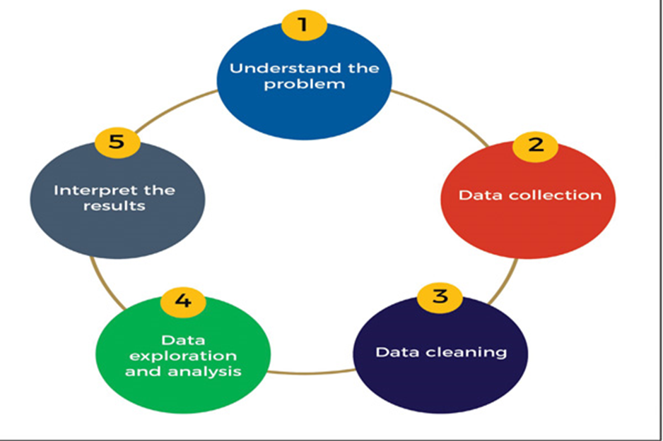

**4.2   Language and platform used**

**4.2.1  Python**

Python is a high-level, interpreted programming language known for its simplicity and readability. Created by Guido van Rossum and first released in 1991, Python's design philosophy emphasizes code readability and syntax that allows programmers to express concepts in fewer lines of code. It supports multiple programming paradigms, including procedural, object-oriented, and functional programming.

·

#### Key Features

·        **Readability**: Python's syntax is clear and intuitive, making it accessible to beginners and reducing the learning curve.

·        **Extensive Standard Library**: Python's standard library supports many common programming tasks such as file I/O, system calls, and even web browsing.

·        **Dynamic Typing**: Variables in Python are not bound to a specific data type, which enhances flexibility but can lead to runtime errors if not handled properly.

·        **Interpreted Language**: Python code is executed line by line, which makes debugging easier but can affect performance compared to compiled languages

**Community and Ecosystem**: Python has a vast and active community, which contributes to a rich ecosystem of third-party libraries and frameworks.

#### Applications

Python is versatile and used across various domains, including:

 ·       **Web Development**: Frameworks like Django and Flask simplify the development of complex web applications.

·       **Automation and Scripting**: Python's straightforward syntax and powerful libraries make it ideal for automating repetitive tasks.

·        **Scientific Computing and Data Analysis**: Python's scientific libraries are widely used for research and data analysis.

·        **Artificial Intelligence and Machine Learning**: With its powerful libraries and frameworks, Python is a top choice for AI and ML projects.

#### 

#### Python in Data Science

Python has become the de facto language for data science due to its simplicity and the powerful libraries available. Here are some of the most important libraries in data science:

**NumPy**: Provides support for large multi-dimensional arrays and matrices, along with a collection of mathematical functions to operate on these arrays.

·        **Pandas**: Offers data structures and functions needed to manipulate structured data seamlessly. It's essential for data cleaning and preparation.

·        **Matplotlib**: A plotting library for creating static, interactive, and animated visualizations in Python.

·        **Seaborn**: Built on top of Matplotlib, Seaborn provides a high-level interface for drawing attractive and informative statistical graphics.

·        **SciPy**: Builds on NumPy and provides additional tools for scientific and technical computing, such as optimization, integration, and statistics.

·        **Scikit-learn**: A machine learning library that provides simple and efficient tools for data mining and data analysis, built on NumPy, SciPy, and Matplotlib..

**4.2.2 Google Colab**

Google Colaboratory, commonly known as Google Colab, is a free, cloud-based Jupyter notebook environment provided by Google. It is designed to facilitate Python coding and data analysis tasks by providing an accessible and collaborative platform. Google Colab is particularly popular among data scientists and machine learning practitioners due to its seamless integration with Google Drive and its ability to leverage powerful hardware like GPUs and TPUs.

Features of Google colab are:

·   **Free Usage**: It provides free access to a GPU and TPU (Tensor Processing Unit), which are useful for training machine learning models that require significant computational power.

·   **Jupyter Notebook Integration**: Colab is based on Jupyter Notebooks, making it easy to write and execute Python code in a collaborative environment. Notebooks can include text, code, equations, and visualizations.

**Easy Sharing and Collaboration**: You can share Colab notebooks just like Google Docs, allowing others to view or edit them in real-time. This is great for team projects or teaching environments.

·   **Built-in Libraries and Tools**: Colab comes pre-installed with many popular libraries such as NumPy, pandas, matplotlib, and TensorFlow, among others. This makes it easy to start working on data analysis, machine learning, and other tasks without needing to install additional software.

·   **Integration with Google Drive**: You can easily access and save your Colab notebooks in Google Drive, making it convenient for storage and version control.

·   **Support for Different Languages**: While primarily used with Python, Colab also supports other languages like R. This flexibility allows users to choose the language that best fits their needs.

·   **Hardware Accelerators**: Colab provides access to GPUs and TPUs for accelerating computations, which is particularly useful for training deep learning models or handling large datasets efficiently.

·   **External Data Sources**: You can easily import datasets from Google Drive, GitHub, and other sources directly into your Colab notebooks, facilitating seamless data manipulation and analysis.

**4.2.3 VS Code**

Visual Studio Code (VS Code) is a popular integrated development environment (IDE) that supports Python development and offers robust features for working with Flask and Python data science libraries. Here's how VS Code integrates with these aspects:

### Integration with Flask:

1.     **Python Extension**: VS Code provides a Python extension that enhances the IDE with features like IntelliSense (code completion), debugging support, syntax highlighting, and code formatting specifically tailored for Python development, including Flask applications.

2.     **Flask Extension**: There are extensions available in the VS Code marketplace specifically for Flask development. These extensions can provide additional features such as Flask project templates, route management, and integration with Flask's debugging capabilities.

3.     **Terminal Integration**: VS Code includes an integrated terminal that allows you to run Flask commands directly within the IDE. This is convenient for starting the Flask development server (flask run), managing virtual environments, and executing other Flask-related tasks without leaving the editor.

4.     **Debugging**: VS Code supports debugging Flask applications using its built-in debugger or external debuggers like pdb. You can set breakpoints, inspect variables, and step through code to troubleshoot issues in your Flask applications effectively.

### Integration with Python Data Science Libraries:

1.     **Jupyter Notebooks**: VS Code has built-in support for Jupyter Notebooks, allowing you to create and edit .ipynb files directly within the IDE. This is useful for interactive data analysis and visualization using libraries like pandas, NumPy, matplotlib, and seaborn.

2.     **Python Data Science Extensions**: The Python extension for VS Code includes features that facilitate data science workflows. It supports code linting, debugging, and IntelliSense for popular data science libraries, making it easier to write and debug code using these libraries.

3.     **Interactive Python Environment**: VS Code can be configured to work with virtual environments and conda environments, providing isolation and management of dependencies required for data science projects involving Python libraries.

4. **Extensions for Data Science**: VS Code has extensions available for specific data science tasks, such as SQL database integration, machine learning model training and deployment, and data visualization using libraries like Plotly or Bokeh

**4.2.4  FLASK**

Flask is a lightweight and flexible Python web framework that provides tools, libraries, and patterns to help developers build web applications quickly and with minimal overhead.

### Key Features of Flask:

1. **Lightweight and Easy to Use**: Flask is designed to be simple and straightforward, making it easy for developers to get started with web development in Python.

2. **Routing**: Flask uses decorators (@app.route) to map URL patterns to Python functions, allowing you to define routes and handle HTTP requests easily.

3. **Templates**: Flask integrates with Jinja2, a popular templating engine for Python. This allows you to render HTML templates dynamically by passing data from Python code to HTML files.

4. **HTTP Request Handling**: Flask provides request and response objects (request and Response) to handle HTTP requests and responses, making it easy to work with form data, cookies, headers, etc.

5. **Extensions**: Flask has a rich ecosystem of extensions that add additional functionality to your applications, such as authentication, database integration (e.g., SQLAlchemy), RESTful APIs (e.g., Flask-RESTful), and more.

6. **Built-in Development Server**: Flask comes with a built-in development server that you can use to run and test your applications locally during development.

7. **RESTful Support**: While Flask itself is not opinionated about RESTful design, it provides extensions like Flask-RESTful that simplify the creation of RESTful APIs.

8. **Integration with Other Libraries**: Flask integrates well with other Python libraries and frameworks, allowing you to extend its functionality as needed for your projects.

9. **Scalability**: Flask is suitable for building small to medium-sized web applications and APIs. It can be scaled by integrating with other tools and libraries for larger applications.

10. **Community and Documentation**: Flask has a strong community and comprehensive documentation, making it easy to find support, tutorials, and examples to help you learn and use the framework effectively.

**4.2.5  VERCEL**

Vercel is a cloud platform that specializes in deploying serverless functions and static websites. It is known for its simplicity and focus on optimizing the deployment and hosting process for modern web applications. Here are some key features of Vercel:

1.     **Serverless Deployments**: Vercel supports serverless functions, allowing you to deploy APIs and backend services without managing servers. It integrates

seamlessly with frameworks like Next.js, Nuxt.js, and others that support serverless architectures.

2.     **Static Site Hosting**: Vercel excels at hosting static websites and frontend applications. It automatically optimizes assets, provides global CDN (Content Delivery Network) distribution, and ensures fast loading times for static content.

3.     **Continuous Deployment**: Vercel integrates with Git repositories (GitHub, GitLab, Bitbucket) to enable continuous deployment. It automatically builds and deploys your applications whenever you push changes to your repository, streamlining the deployment workflow.

4.     **Custom Domains and SSL**: You can easily configure custom domains for your applications hosted on Vercel. It provides SSL (Secure Sockets Layer) certificates for all custom domains by default, ensuring secure connections.

5.     **Environment Variables and Secrets**: Vercel allows you to manage environment variables and secrets securely. This is crucial for storing sensitive information like API keys, database credentials, and configuration settings without exposing them in your source code.

6.     **Preview Deployments**: Vercel supports preview deployments, allowing you to generate temporary deployments for each pull request or branch. This enables collaborative development and testing of changes before merging them into the main branch.

7.     **Analytics and Monitoring**: Vercel provides analytics and monitoring tools to track performance metrics, such as deployment times, traffic patterns, and error rates. This helps you optimize and troubleshoot your applications effectively.

8.     **Collaboration and Teams**: Vercel offers team collaboration features, allowing multiple team members to work on and manage projects together. It includes access control, collaboration tools, and integration with project management workflows.

9.     **Extensibility**: Vercel supports integration with other services and tools through its API and webhooks. This allows you to automate deployment workflows, integrate with CI/CD pipelines, and extend functionality as needed.

10. **Support and Documentation**: Vercel provides comprehensive documentation, tutorials, and support resources to help developers get started and troubleshoot issues effectively. Their support team is responsive and actively engages with the community.

**5.**  **IMPLEMENTATION**

**5.1  Gathering Requirements and Defining Problem Statement**

This is the first step wherein the requirements are collected from the clients to understand the deliverables and goals to be achieved after which a problem statement is defined which has to be adhered to while development of the project.

**5.2  Data collecting and importing**

Data collection is a systematic approach for gathering and measuring information from a variety of sources in order to obtain a complete and accurate picture of an interest area. It helps an individual or organization to address specific questions, determine outcomes and forecast future probabilities and patterns.

The data IBM hr_analytics has been collected from Kaggle.

Data importing is referred to as uploading the required data into the coding environment from internal sources (computer) or external sources (online websites and data repositories). This data can then be manipulated, aggregated, filtered according to the requirements and needs of the project.

**5.2.1 Packages Used:**

**Read**: The goal of read is to provide a fast and friendly way to read rectangular data (like csv, tsv, and fwf). It is designed to flexibly parse many types of data found in the wild, while still cleanly failing when data unexpectedly changes. To accurately read a rectangular dataset with readr, one needs to combine two pieces: a function that parses the overall file, and a column specification.

Functions Used:

**Read_csv ()**: It is a wrapper function for [read.table() that](https://renenyffenegger.ch/notes/development/languages/R/functions/read/table) mandates a comma as separator and uses the input file's first line as header that specifies the table's column names. Thus, it is an ideal candidate to read [CSV files.](https://renenyffenegger.ch/notes/development/Data/exchange/formats/CSV/index) It has an additional parameter of url() which is used to pull live data directly from GitHub repository.

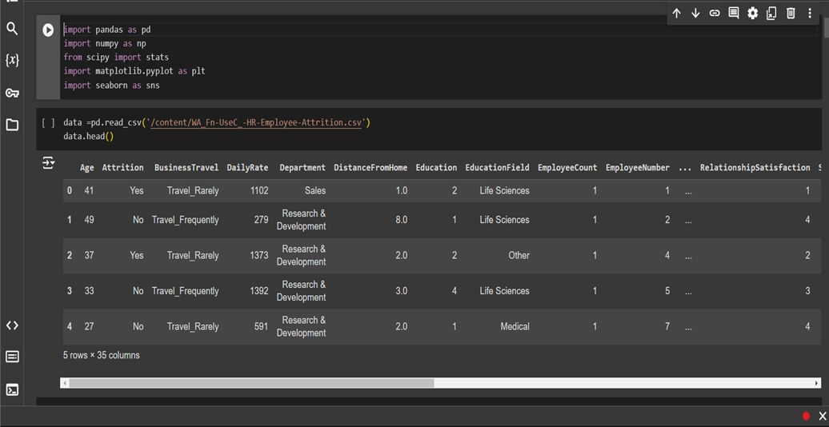

### 5.3     Data Pre-processing

Data is the most imperative aspect of Analytics and Machine Learning. Everywhere in computing or business, data is required. But many a times, the data may be incomplete, inconsistent or may contain missing values when it comes to the real world. If the data is corrupted then the process may be impeded or inaccurate results may be provided. Hence, Data cleaning is considered a foundational element of the basic data science.

Data Cleaning means the process by which the incorrect, incomplete, inaccurate, irrelevant or missing part of the data is identified and then modified, replaced or deleted as needed.

#### 5.3.1  Dealing with Missing values

With reference to the ibm_hr dataset, it may contain many null values or incorrect value simply because of inconsistency in reporting cases and testing statistics by countries and states. Hence various functions are used to clean this data.

Packages Used:

**Pandas and Numpy**

Functions used:

is.na(): In Python, missing values are represented by the symbol NA (not available). Impossible values (e.g., dividing by zero) are represented by the symbol NaN (not a number). This function is used to check if a dataset contains NA values Or not

* Dropping unnecessary columns in a DataFrame

* Changing the index of a DataFrame

* Using .str() methods to clean columns

* Using the DataFrame.applymap() function to clean the entire dataset, element-wise

* Renaming columns to a more recognizable set of labels.
* Skipping unnecessary rows in a CSV file

Missing values are found

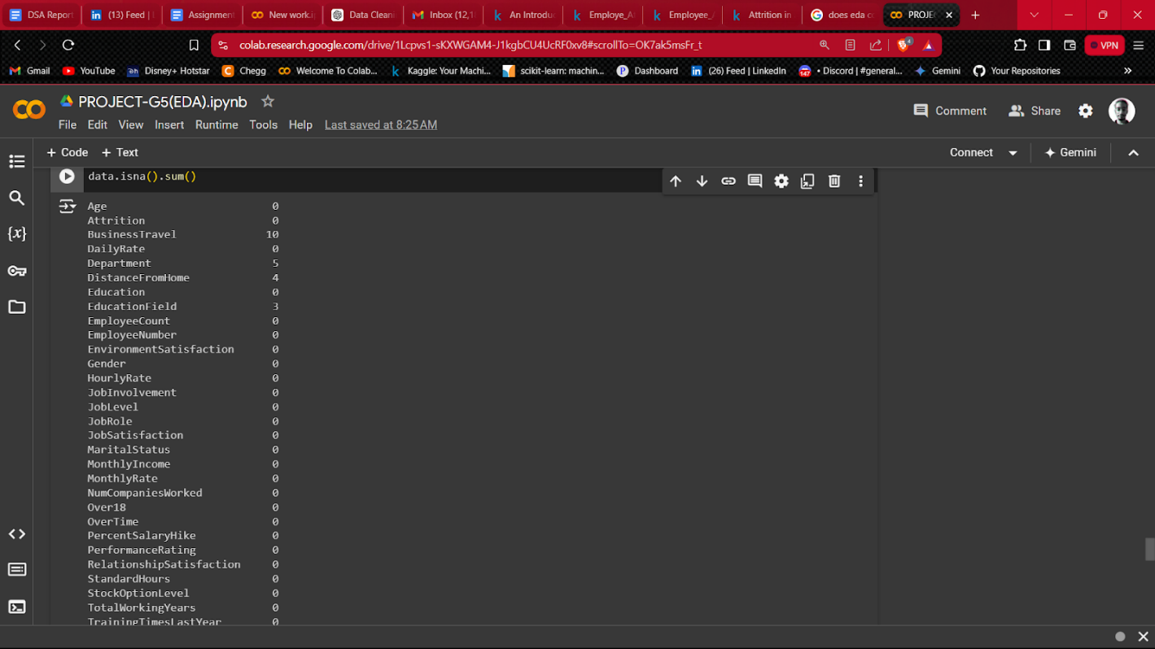

Removing  missing values

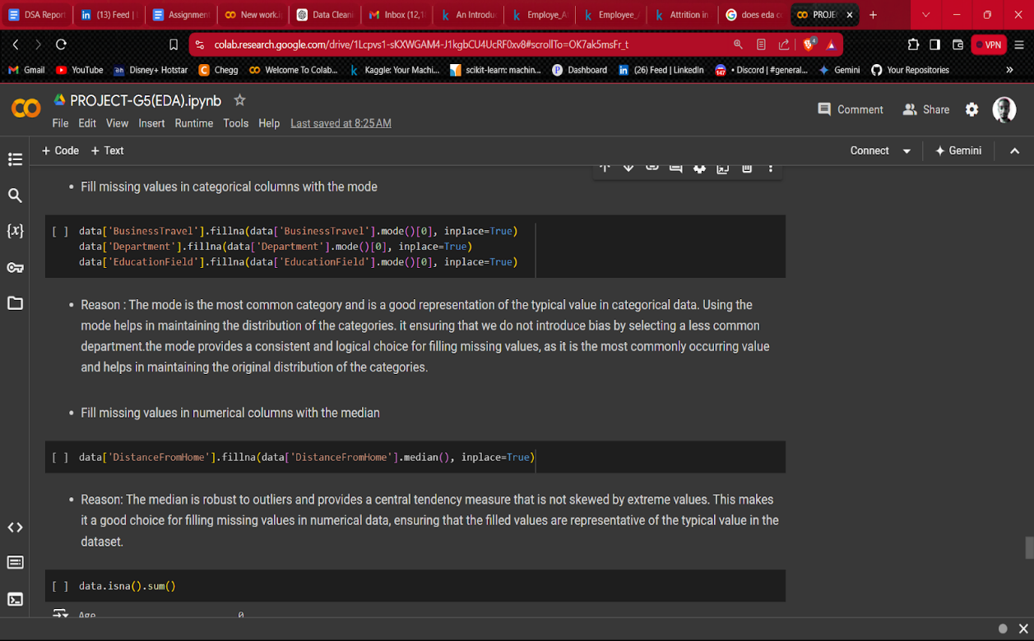

Missing values removed

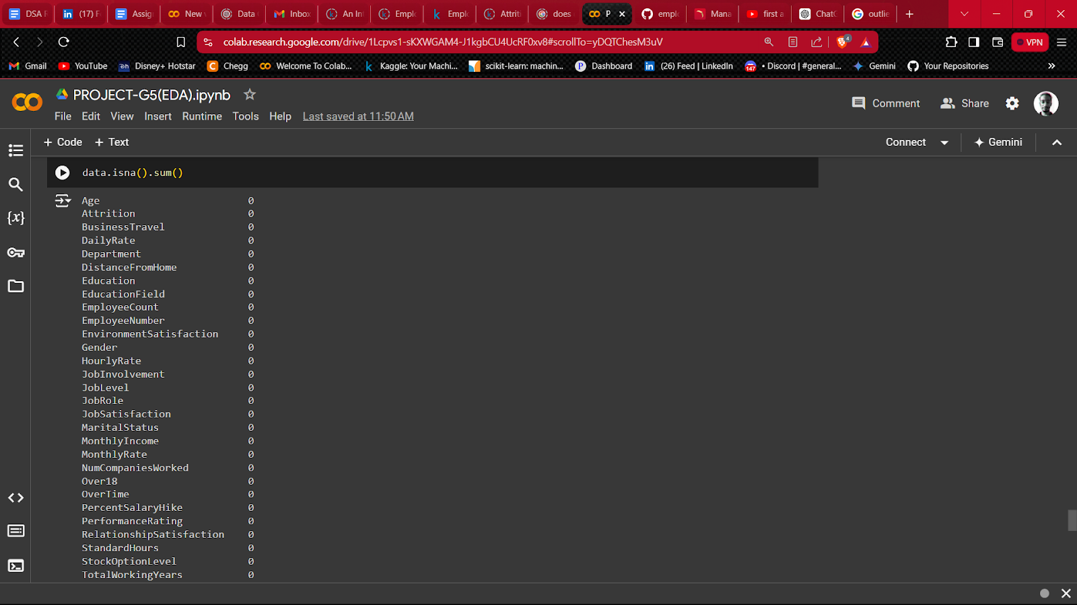

#### 5.3.2  Outlier correction

Outliers are data points that deviate significantly from the majority of the data. They can result from measurement errors, data entry mistakes, or natural variability in the data. Outlier correction is crucial in data preprocessing because outliers can distort statistical analyses and predictive models, leading to inaccurate results. There are several methods to identify and correct outliers:

1. Standard Deviation Method: This method assumes that the data follows a normal distribution. Data points that fall outside a specified number of standard deviations from the mean are considered outliers. For instance, in a normal distribution, about 99.7% of data points fall within three standard deviations from the mean. Hence, any data point beyond this range could be flagged as an outlier.

2.Z-score Method: The Z-score indicates how many standard deviations a data point is from the mean. Data points with Z-scores greater than a certain threshold

3.(typically 3 or -3) are considered outliers. This method is similar to the standard deviation method but provides a normalized score for easier comparison.

4.Percentile Method: This method involves setting lower and upper percentile thresholds. Data points that fall below the lower percentile or above the upper percentile are considered outliers. For example, the 1st and 99th percentiles can be used as thresholds.

5.Interquartile Range (IQR) Method: The IQR method is a robust technique that doesn’t assume any specific data distribution. The IQR is the range between the first quartile (Q1) and the third quartile (Q3). Data points that fall below Q1 - 1.5*IQR or above Q3 + 1.5*IQR are considered outliers.

Values are stored in a variable called ‘numerical cols’ and visualized using box plot to check for outliers.

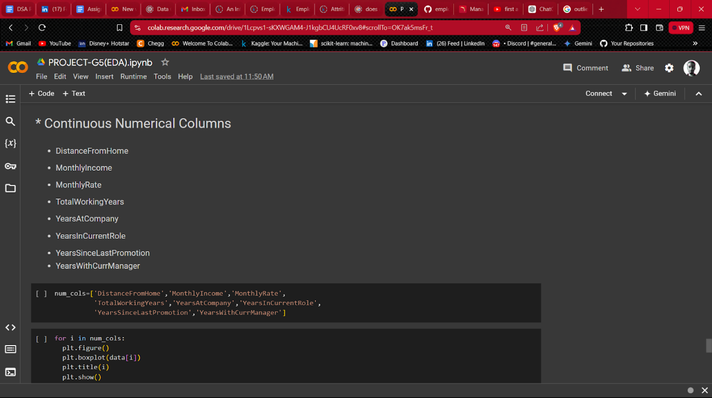

Used **clipping** function to remove outliers.

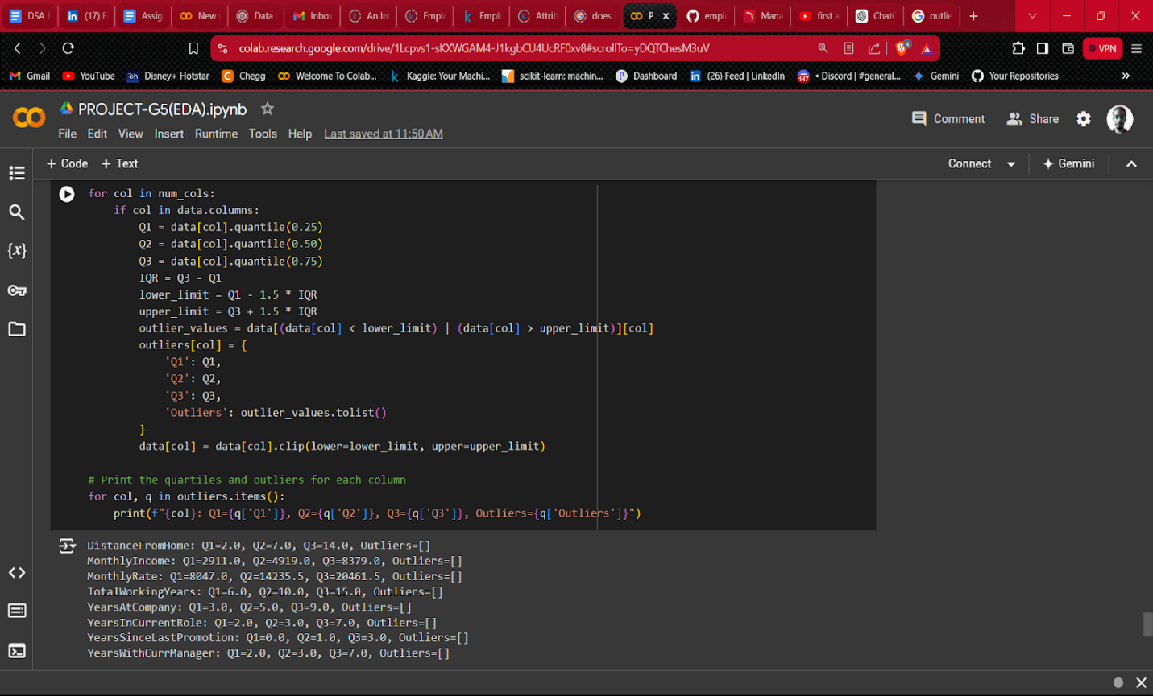

### 5.4  Data Exploration

Exploratory Data Analysis (EDA) is an approach to analyzing data sets to summarize their main characteristics, often with visual methods. The goal of EDA is to discover patterns, spot anomalies, test hypotheses, and check assumptions with the help of summary statistics and graphical representations.

1. Descriptive Statistics: This involves calculating summary statistics to understand the basic properties of the data.

* Measures of Central Tendency: Mean, median, and mode.
* Measures of Dispersion: Range, variance, standard deviation, and interquartile range (IQR).
* Distribution: Skewness and kurtosis.

1. Data Visualization: Visual techniques help in understanding the data distribution, relationships, and patterns.

* Histograms: Show the frequency distribution of a single variable.
* Box Plots: Visualize the distribution of data and identify outliers.
* Scatter Plots: Show relationships between two continuous variables.
* Bar Charts: Compare categorical data.
* Pie Charts: Represent parts of a whole.
* Heatmaps: Display data in a matrix format, useful for correlation analysis.

1. Univariate Analysis: Analysis of a single variable to understand its distribution and characteristics.

* Frequency Distribution: Count the occurrences of each unique value.
* Probability Plots: Compare the distribution of a dataset to a theoretical distribution.

1. Bivariate Analysis: Analysis of two variables to understand the relationship between them.

* Correlation Matrix: Shows the correlation coefficients between multiple variables.
* Pair Plots: Visualize the pairwise relationships between several variables.

1. Multivariate Analysis: Analysis involving more than two variables.

* Principal Component Analysis (PCA): Reduces dimensionality while preserving as much variance as possible.
* Factor Analysis: Identifies underlying relationships between variables.
* Cluster Analysis: Groups similar observations together.

#### 5.4.1 Univariate analysis

1. Attrition values are checked to evaluate how much percent of employees left the company.

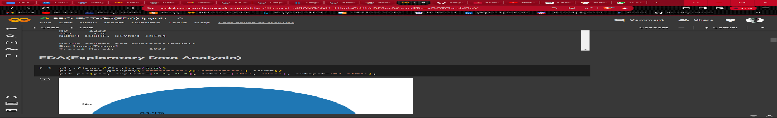

1. Distribution of employee age across attrition categories.

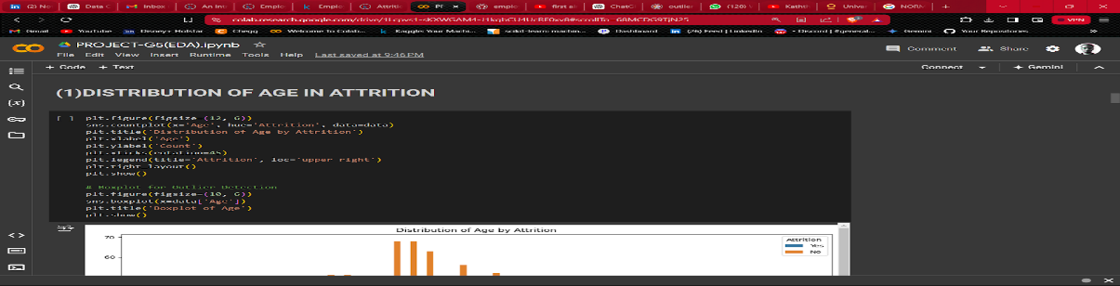

1. Distribution of business travel across Attrition

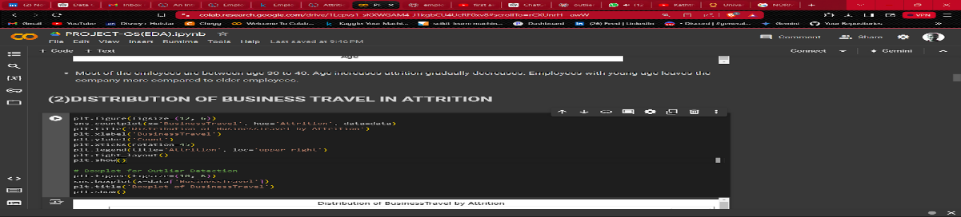

1. Distribution of department in Attrition.

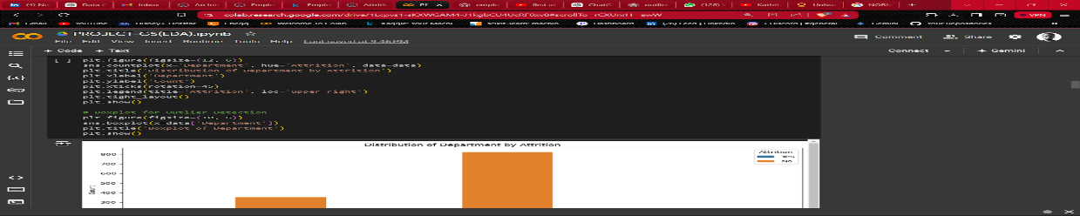

1. Distribution of distance from home in Attrition.

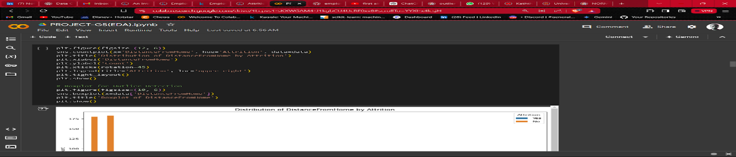

6.Distribution of education field in Attrition

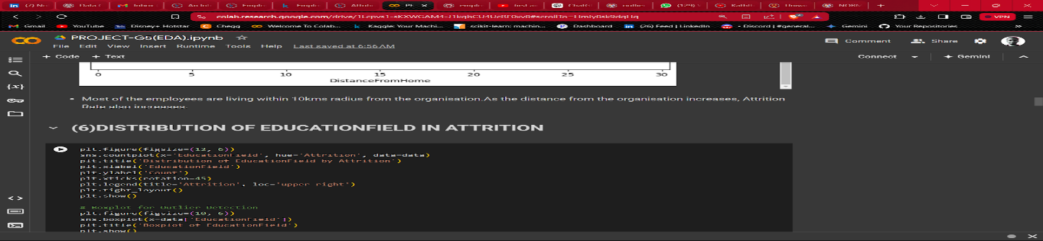

7.Distribution of Environment satisfaction in Attrition

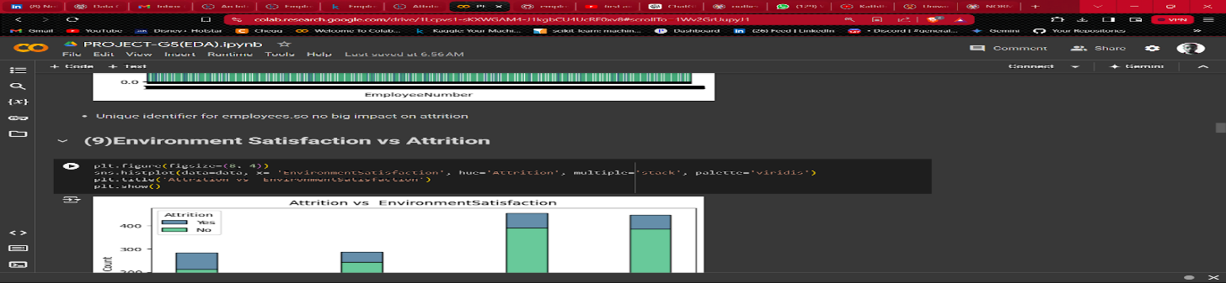

8.Distribution of Gender in Attrition

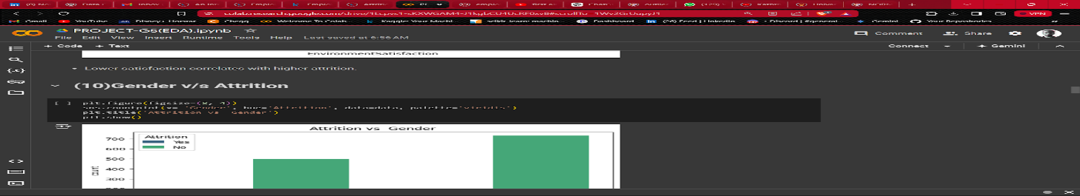

9.Distribution of Job involvement and Attrition

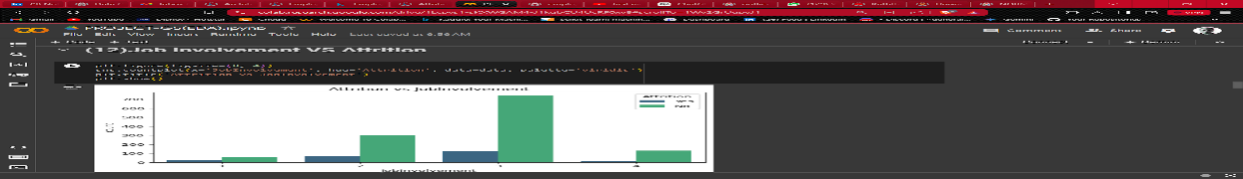  
10.Distribution of Job level in Attrition

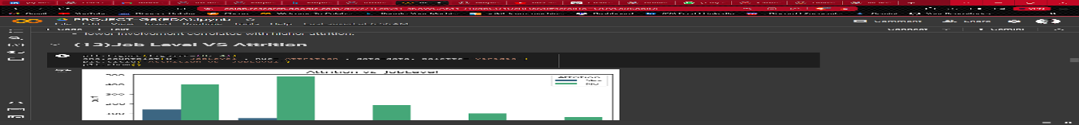11.Distribution of Job role, Job satisfaction



12.Distribution of Monthly income, Num of companies worked



13.Distribution of Overtime on Attrition



14.Distribution of Percent salary hike on Attrition

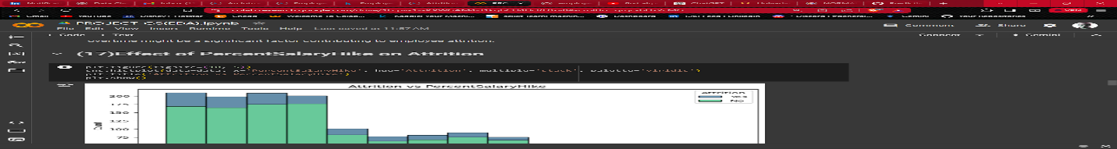

15.Distribution of Relationship satisfaction on Attrition

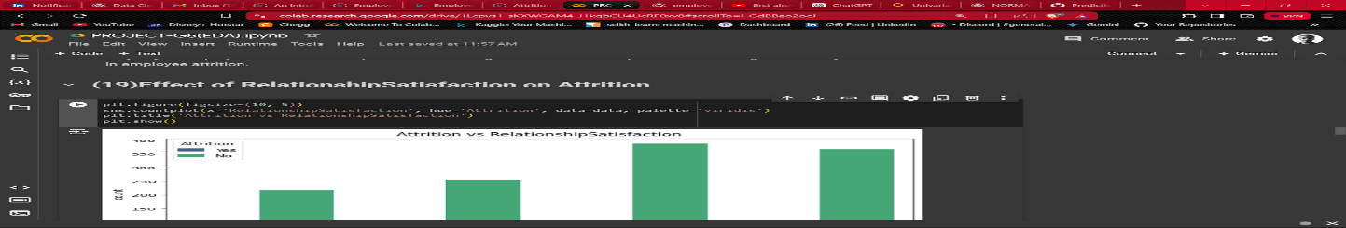

16.Distribution of  Total working years,Training times last year,Work life balance,Years at company,years in current role,Years since last promotion,Years with curr manager

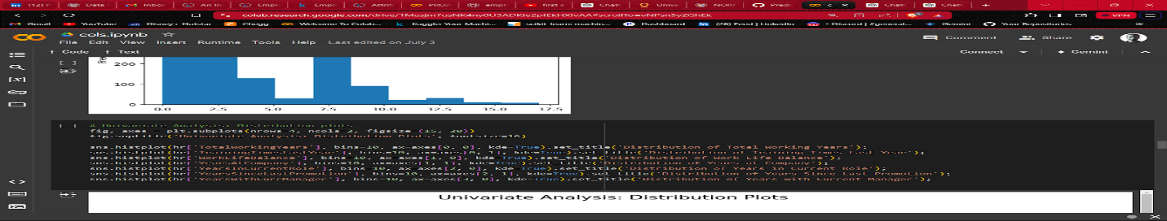

Distribution of  Total working years,Training times last year,Work life balance,Years at company,years in current role,Years since last promotion,Years with curr manager in Attrition

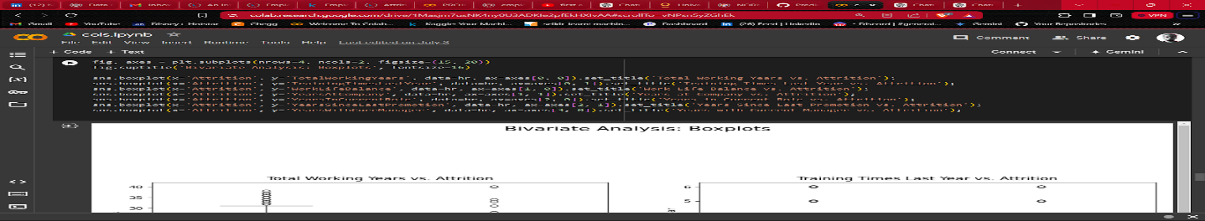

#### 5.4.2  Data Encoding

Removing Unnecessary cols that doe not have an impact on Target variable(Attrition).

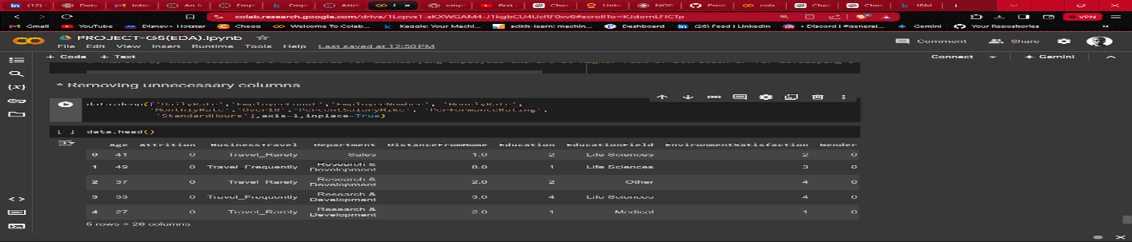

Using Label encoder to encode categorical values to numerical :

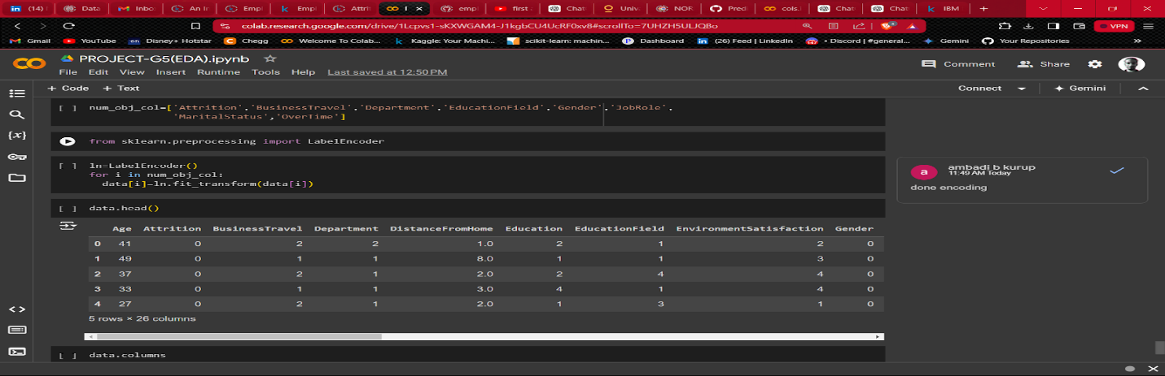

#### 5.4.3  Bi-variate analysis

Using corelation matrix we create a Heatmap for better understanding of encoded data.

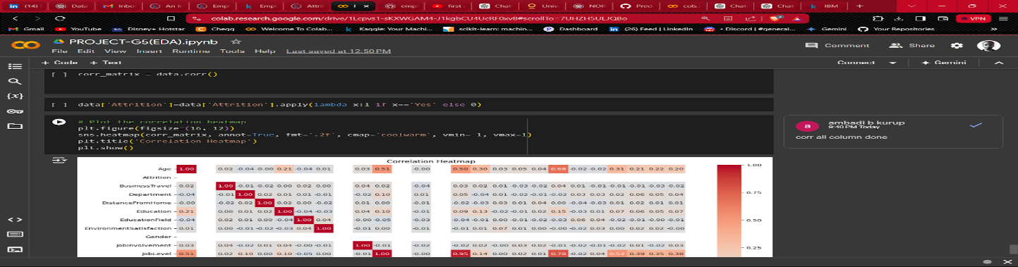

### 5.5   Saving the file

File is saved in .csv format

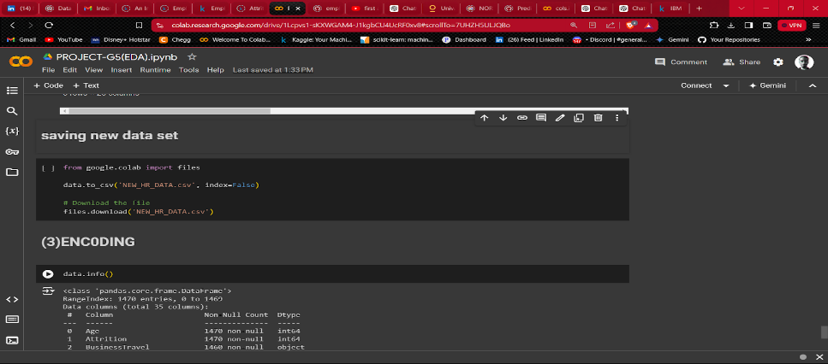

### 5.6  Feature Reduction

Feature reduction, also known as dimensionality reduction, is a process used in machine learning and statistics to reduce the number of input variables in a dataset. This can improve the performance of models by eliminating redundant and irrelevant features, reducing overfitting, and making the data easier to visualize and interpret.

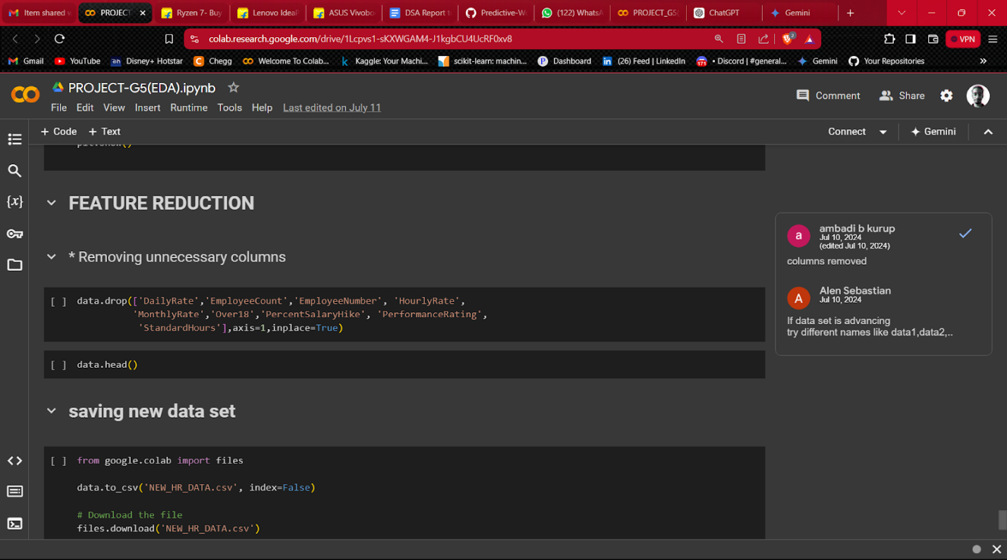

**5.7 Feature engineering**

**Added new features:**

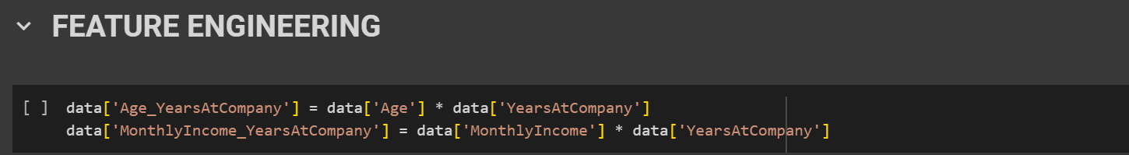





**5.8 Saving final dataset**

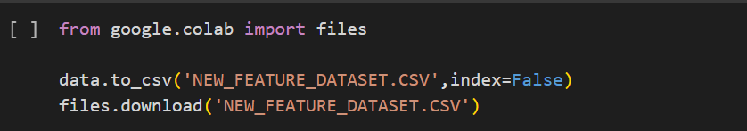

**6. RESULT**

**6.1  Outlier checking**

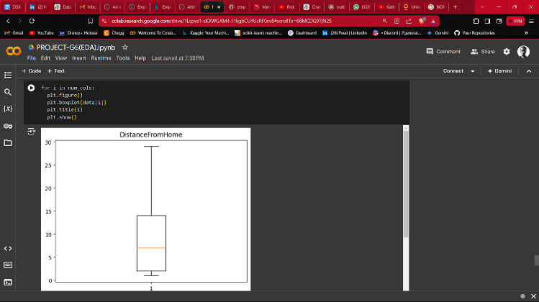       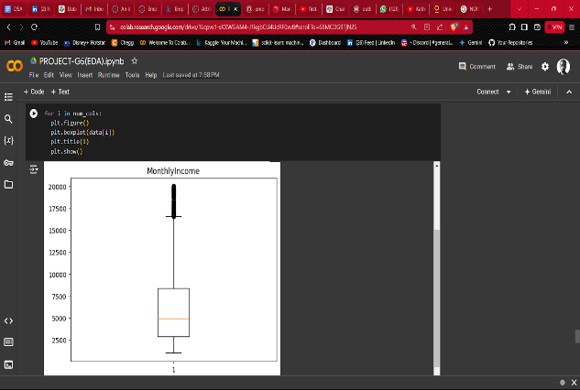    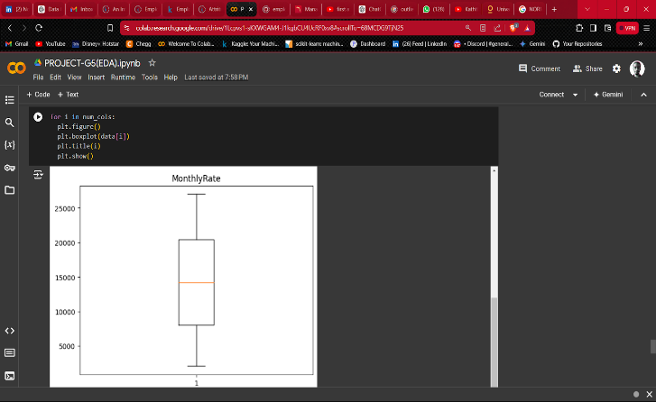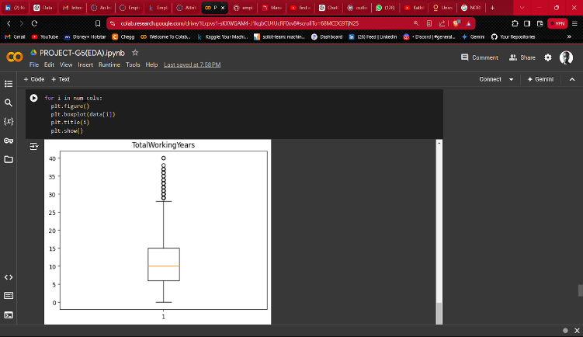

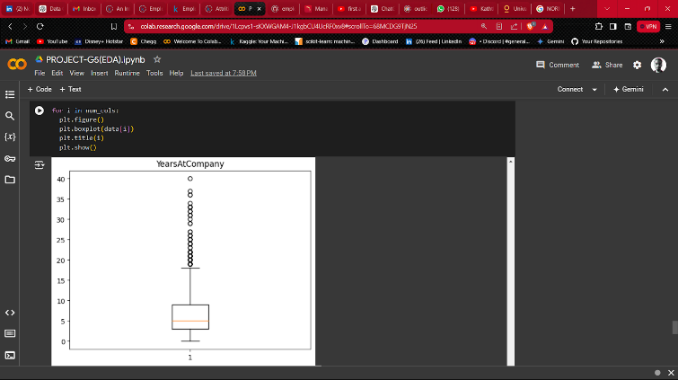  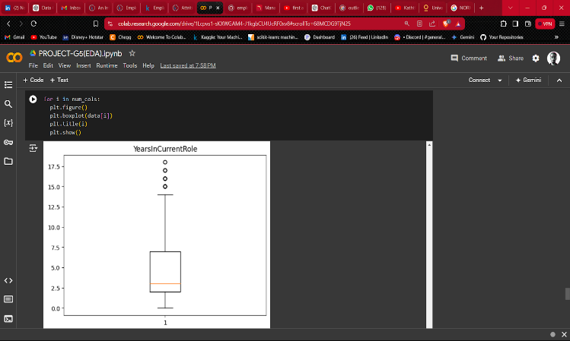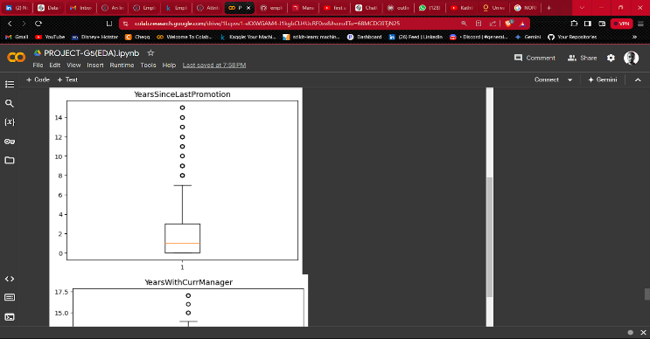   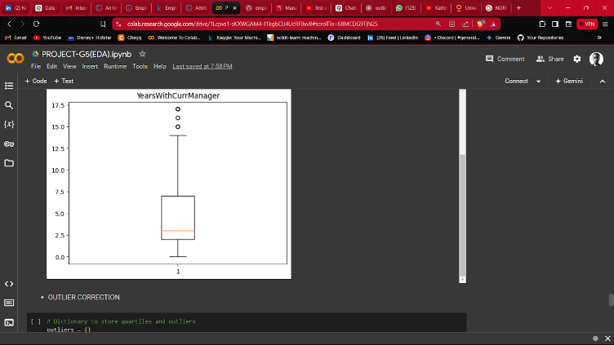

Outlier is found and successfully removed

* 1. **Univariate analysis**

1.Attrition analysis

*Majority of employees didn't leave the organization.

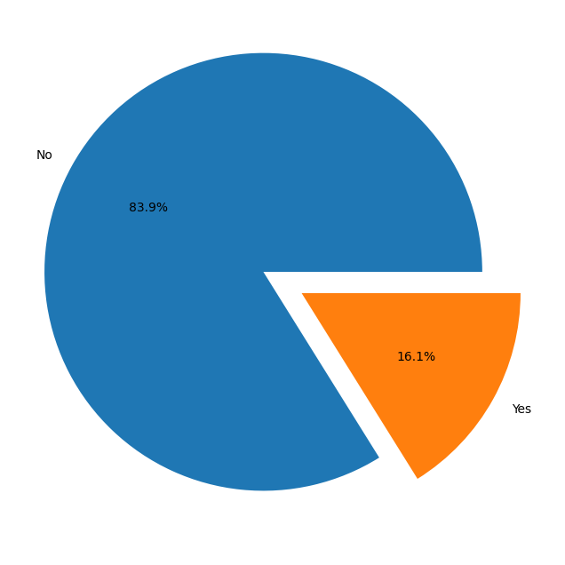

2.Age v/s Attrition

* Most of the employees are between age 30 to 40. Age increases attrition gradually decreases. Employees with young age leaves the company more compared to elder employees.

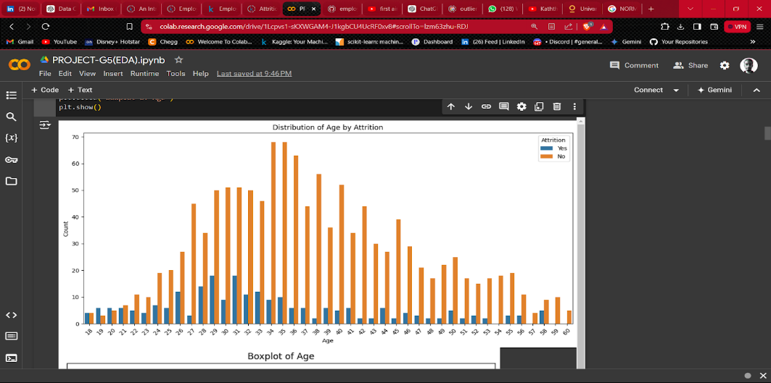

3.Business Travel v/s Attrition

* Most of the employees in the organization Travel Rarely.
* Highest employee attrition can be observed by those employees who Travels Frequently
* Lowest employee attrition can be observed by those employees who are Non-Travel.

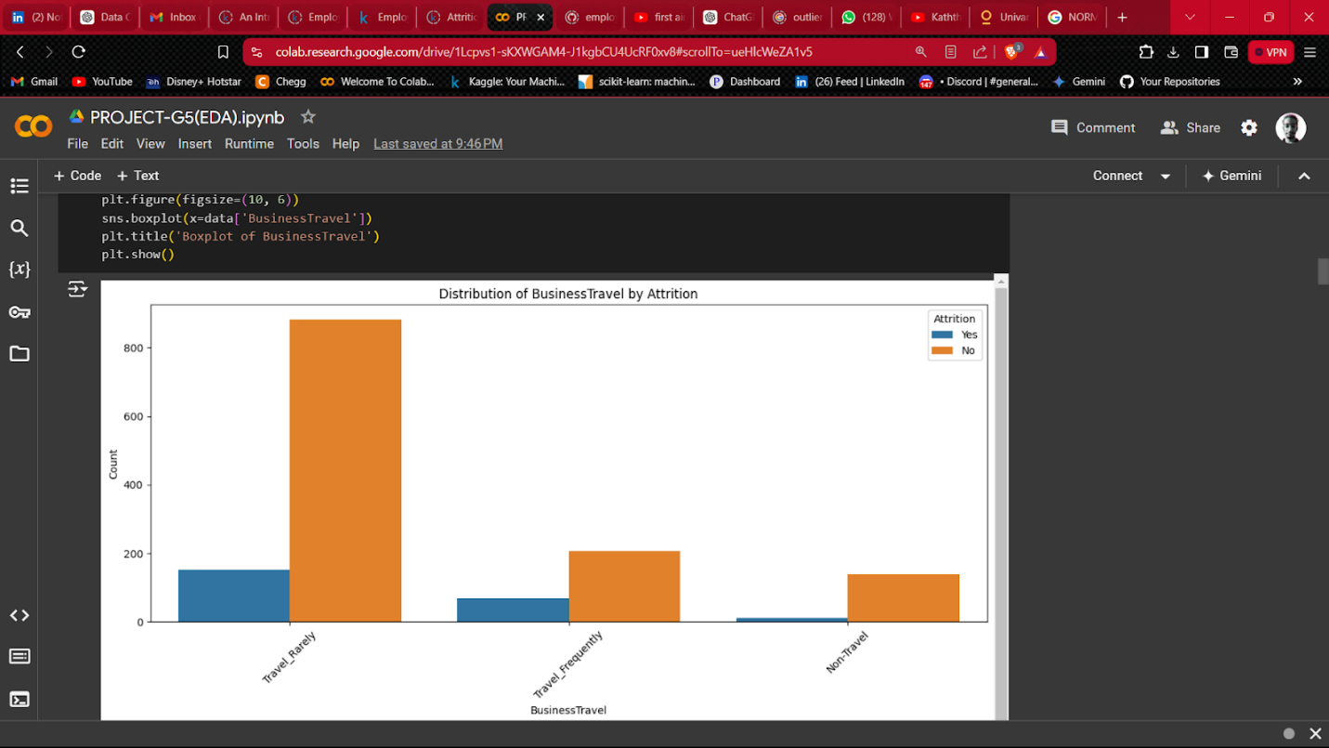

4.Department v/s Attrition

* Most of the employees are from Research & Development Department

* Highest Attrition is in the Sales Department.

* Human Resources Department Attrition rate is also very high.

* Attrition in Research & Development Department is least compared to other departments.

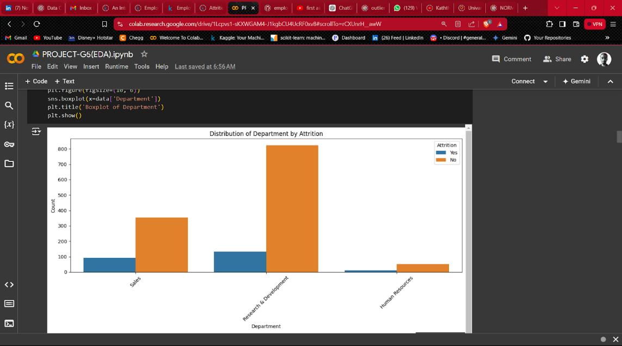

5.Distance from home v/s Attrition

* Most of the employees are living within 10kms radius from the organisation.As the distance from the organisation increases, Attrition Rate also increases.

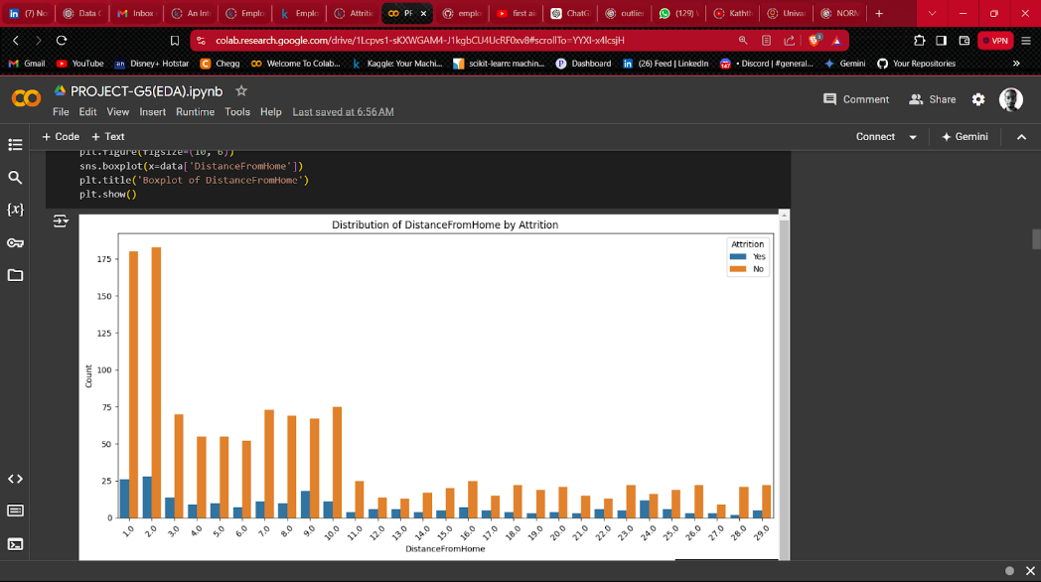

6.Education field v/s Attrition

* Most of the employees are either from Life Science or Medical Education Field. Very few employees are from Human Resources Education Field. Education Fields like Human Resources, Technical, Marketing is having very high attrition rate. This may be because of work load becuase there are very
* few employees in these education fields compared to education field with less attrition rate.

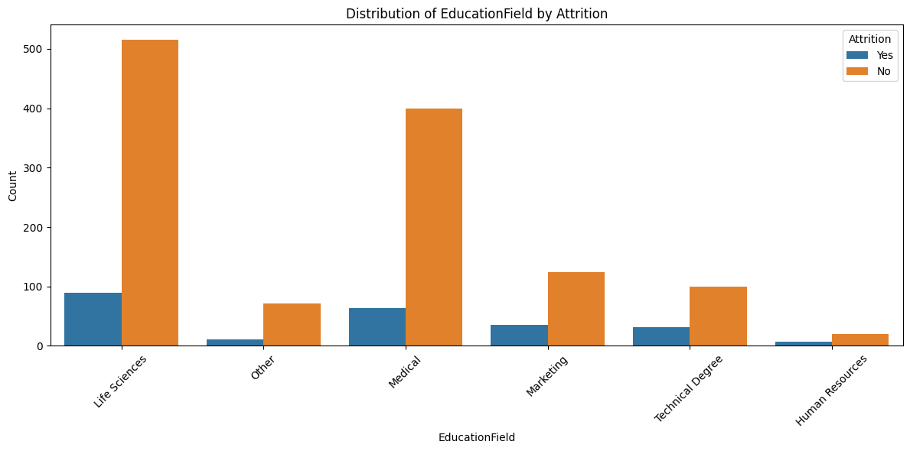

* 1. Environment satisfaction V/s Attrition

* Lower satisfaction correlates with higher attrition.

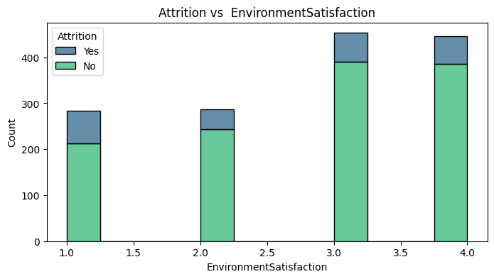

8.Gender v/s Attrition

* Male employees are higher in proportion than female.so Attrition in male is higher compared to females.

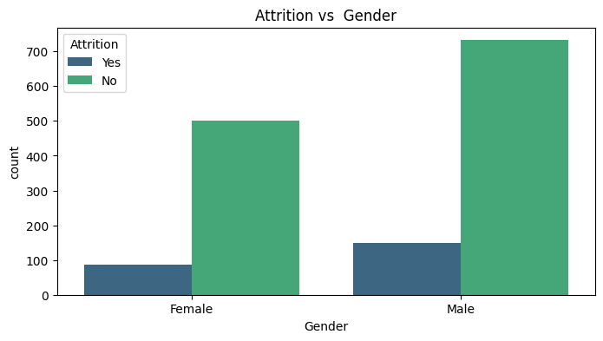

9.Job involvement v/s Attrition

* Lower involvement correlates with higher attrition.

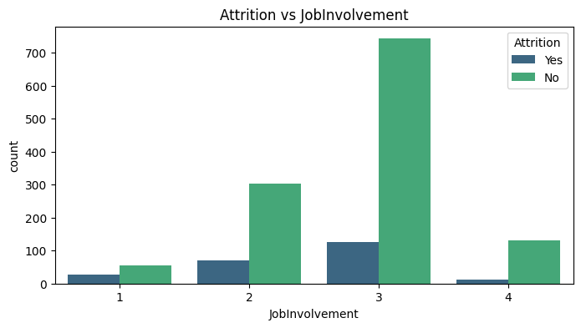

10. Job level v/s Attrition

* Most of the employees in the organization are at Entry Level or Junior Level. Highest Attrition is at the Entry Level.

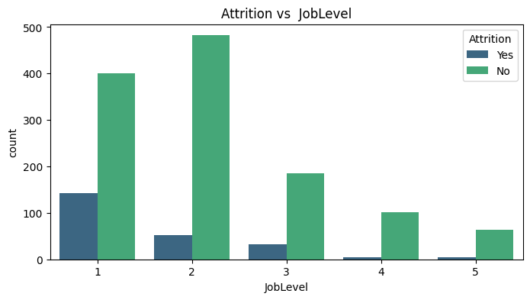

11. Job role v/s Attrition

* Laboratory technician is having higher attrition followed by sales executive,Research scientist and sales representative.

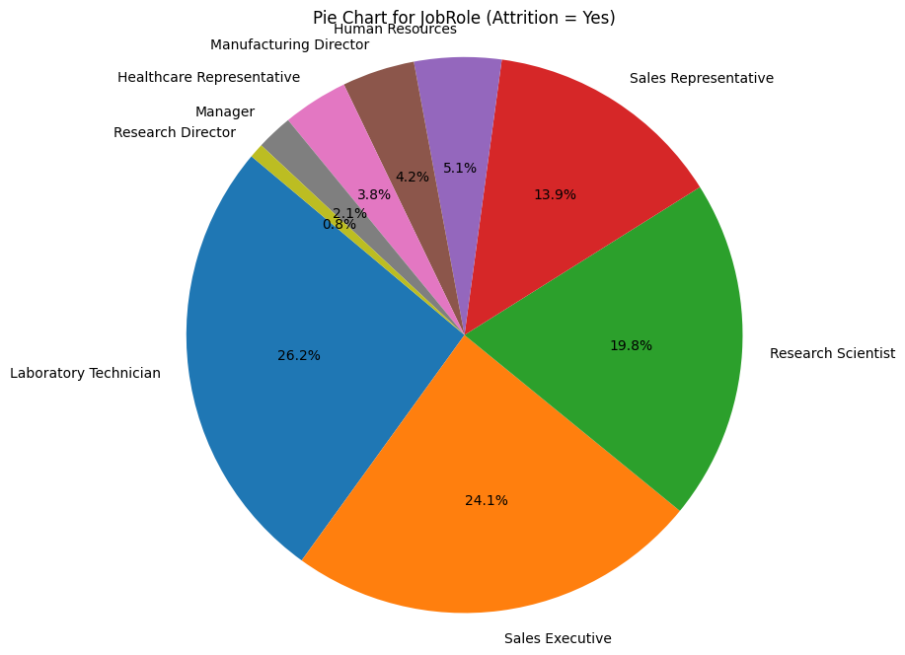

12. Job satisfaction v/s Attrition

* JobSatisfaction [1 'Low' 2 'Medium' 3 'High' 4 'Very High']
* Most of people are unhappy with their current job and are likely to leave the company.

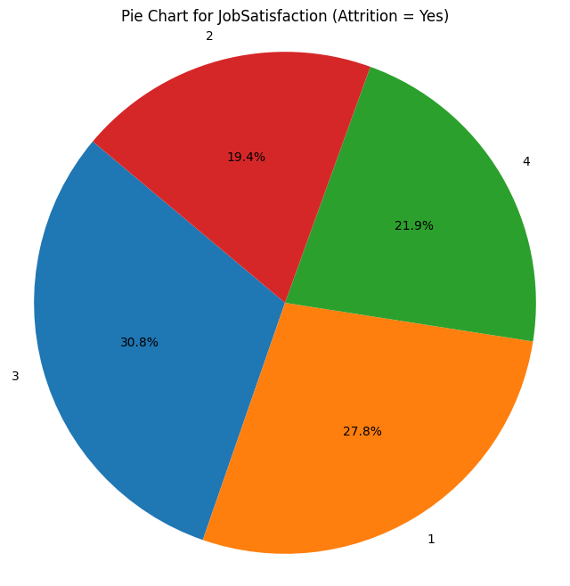

13. Monthly income, Num of companies worked v/s Attrition

* MonthlyIncome: Higher income tends to correlate with lower attrition.
* NumCompaniesWorked : Employees who worked at more companies tend to have higher attrition.

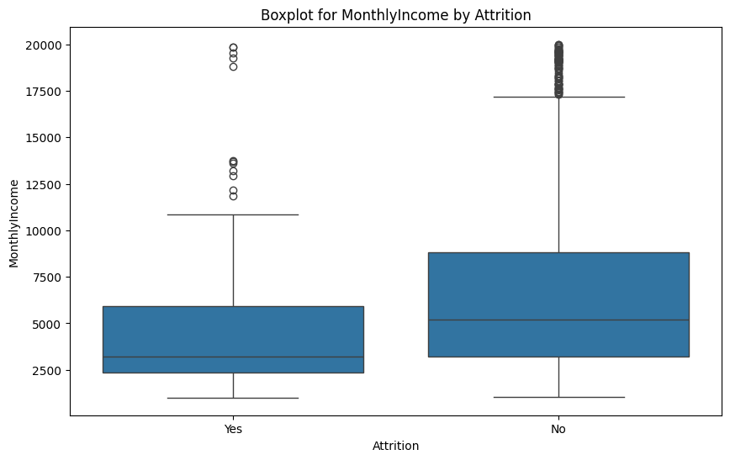

14.  Overtime v/s Attrition

* Employees who work overtime have a higher attrition rate compared to those who do not work overtime. This indicates that working overtime might be a significant factor contributing to employee attrition.

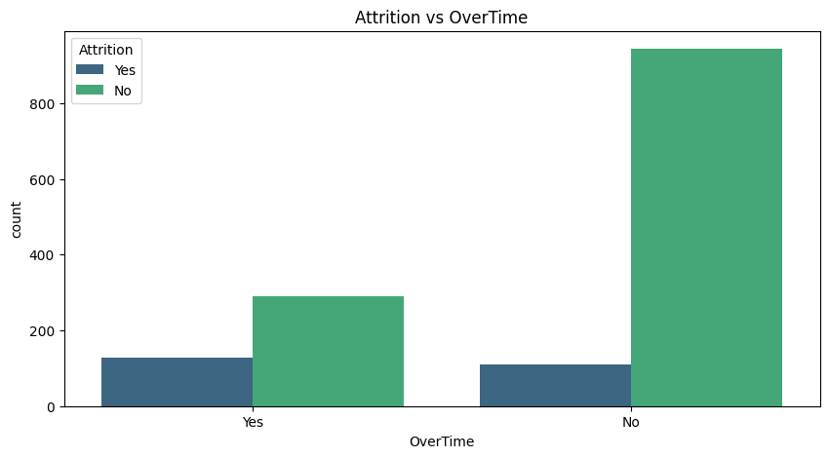

15 . Percent salary hike v/s Attrition

* Very Few employees are getting a high percent salary hike.
* As the amount of percent salary increases the attrition rate decreases

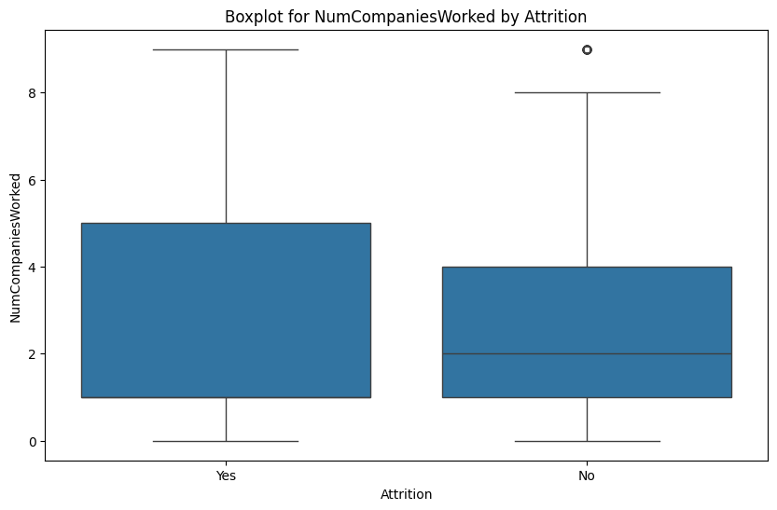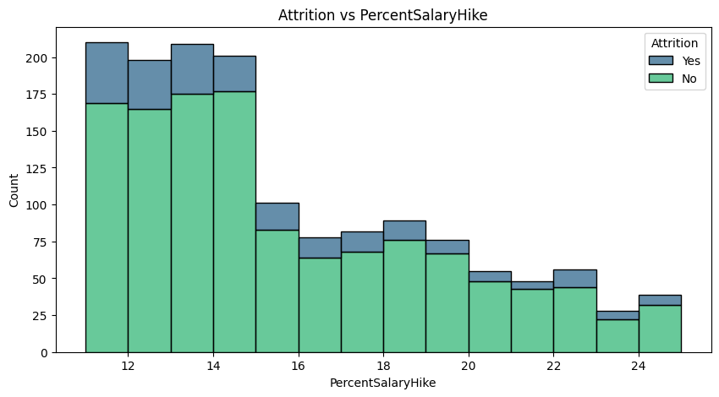

16 .  Relationship satisfaction v/s Attrition

* Employees with lower relationship satisfaction ratings have higher attrition rates. This suggests that relationship satisfaction with colleagues and management might significantly influence an employee's decision to stay or leave the company.

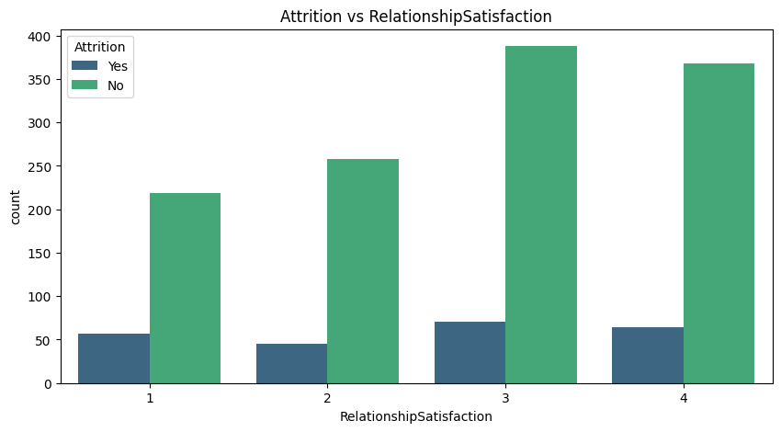

17.  Total working years,Training times last year,Work life balance,Years at company,years in current role,Years since last promotion,Years with curr manager

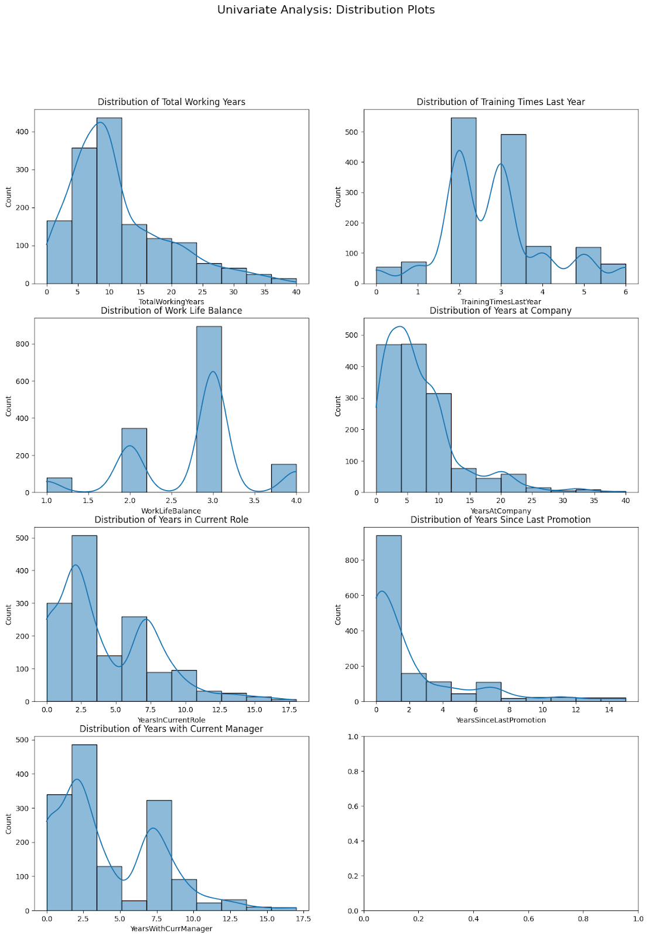

 Total working years,Training times last year,Work life balance,Years at company,years in current role,Years since last promotion,Years with curr manager  v/s Attrition

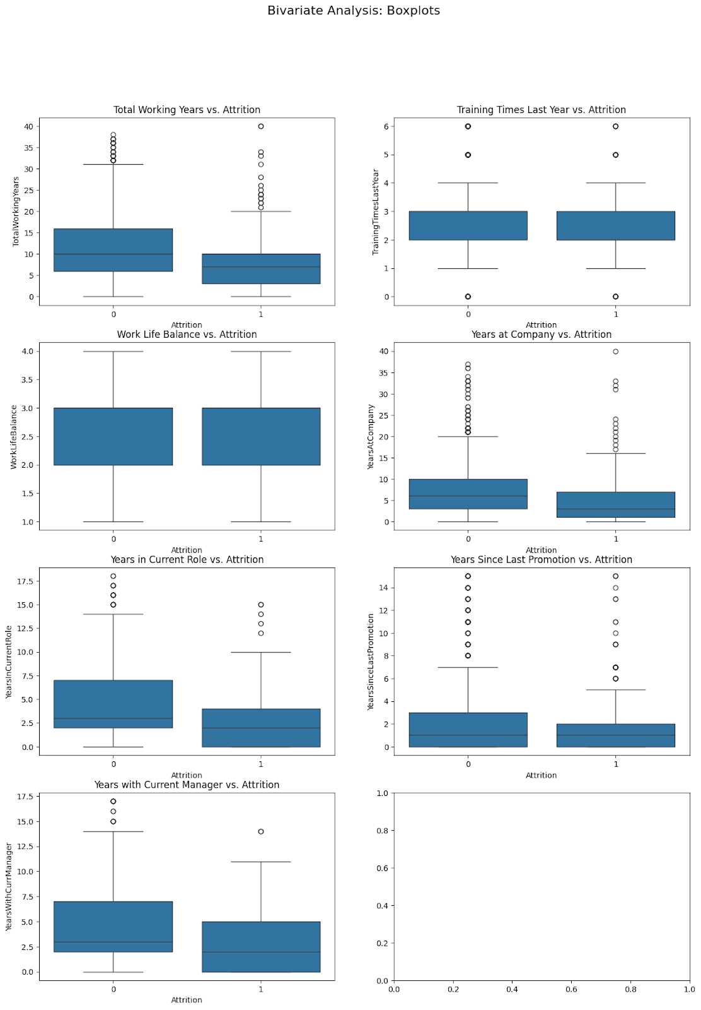

* TotalWorkingYears: Employees with fewer total working years are more likely to have higher attrition rates.
* TrainingTimesLastYear: Indicates that more training times last year are slightly associated with lower attrition. However, the effect is small.

* WorkLifeBalance: Indicates that better work-life balance might be associated with lower attrition, though the effect is minor.

* YearsAtCompany: Employees with fewer years at the company tend to have higher attrition rates.

* YearsInCurrentRole: Employees who have spent fewer years in their current role are more likely to leave.

* YearsSinceLastPromotion: Indicates that the time since the last promotion does not strongly affect the likelihood of leaving.

* YearsWithCurrManager: Employees who have spent less time with their current manager are more likely to leave.

Overall, the analysis indicates that factors related to tenure (such as total working years, years at the company, and years in the current role) and relationships with the manager have more substantial impacts on attrition compared to training and work-life balance.

### 6.3  Data Encoding

Data frame after removing cols:

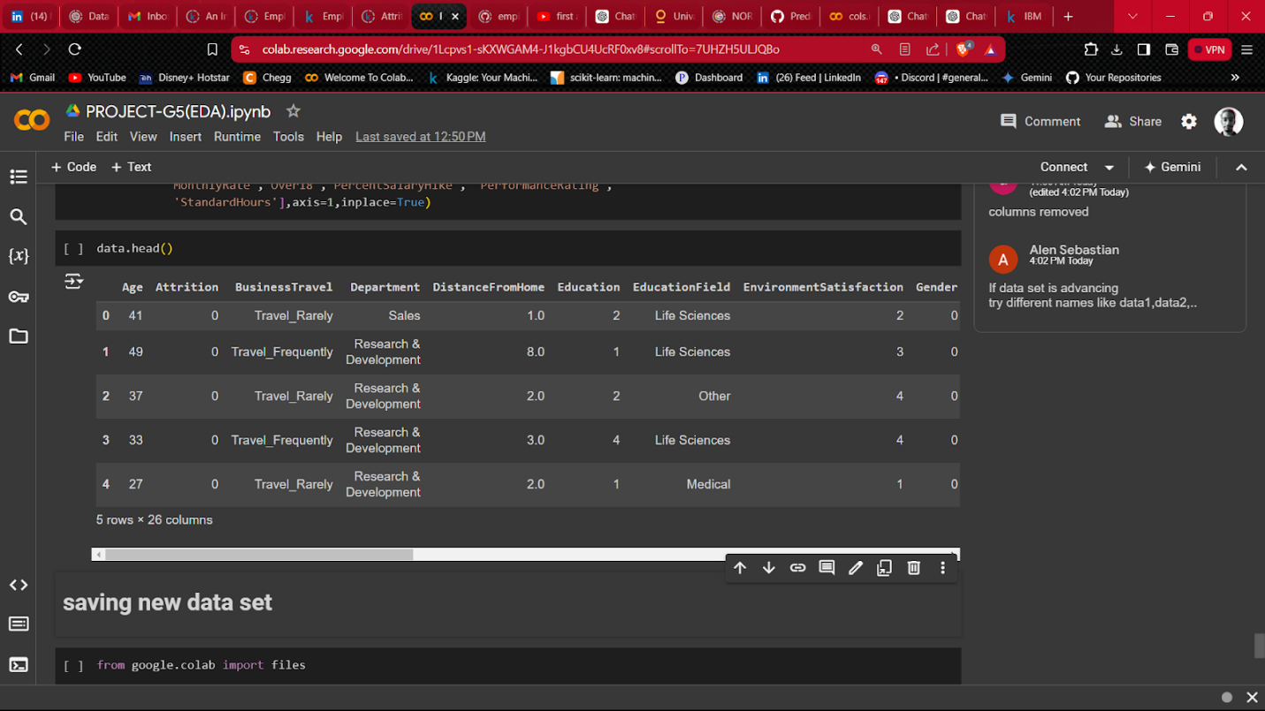

using label encoder to encode values to numerical:

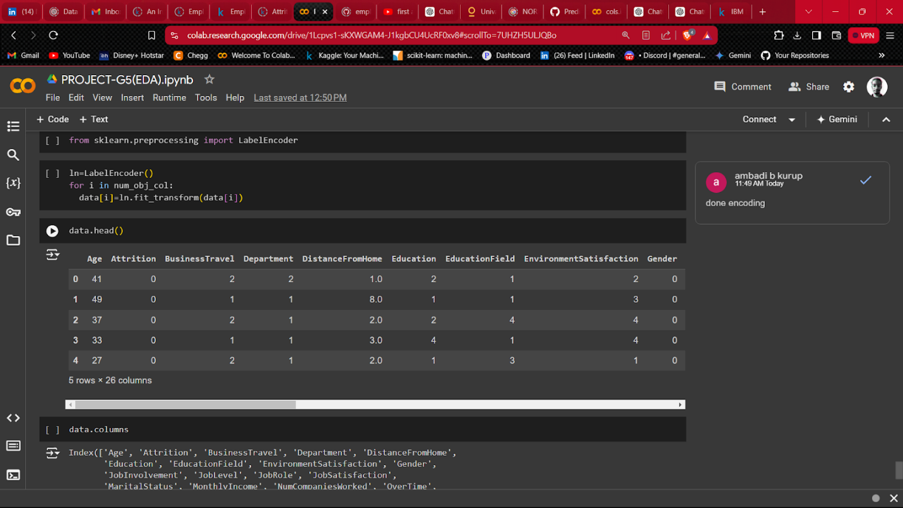

**6.4   Bi-variate  analysis**

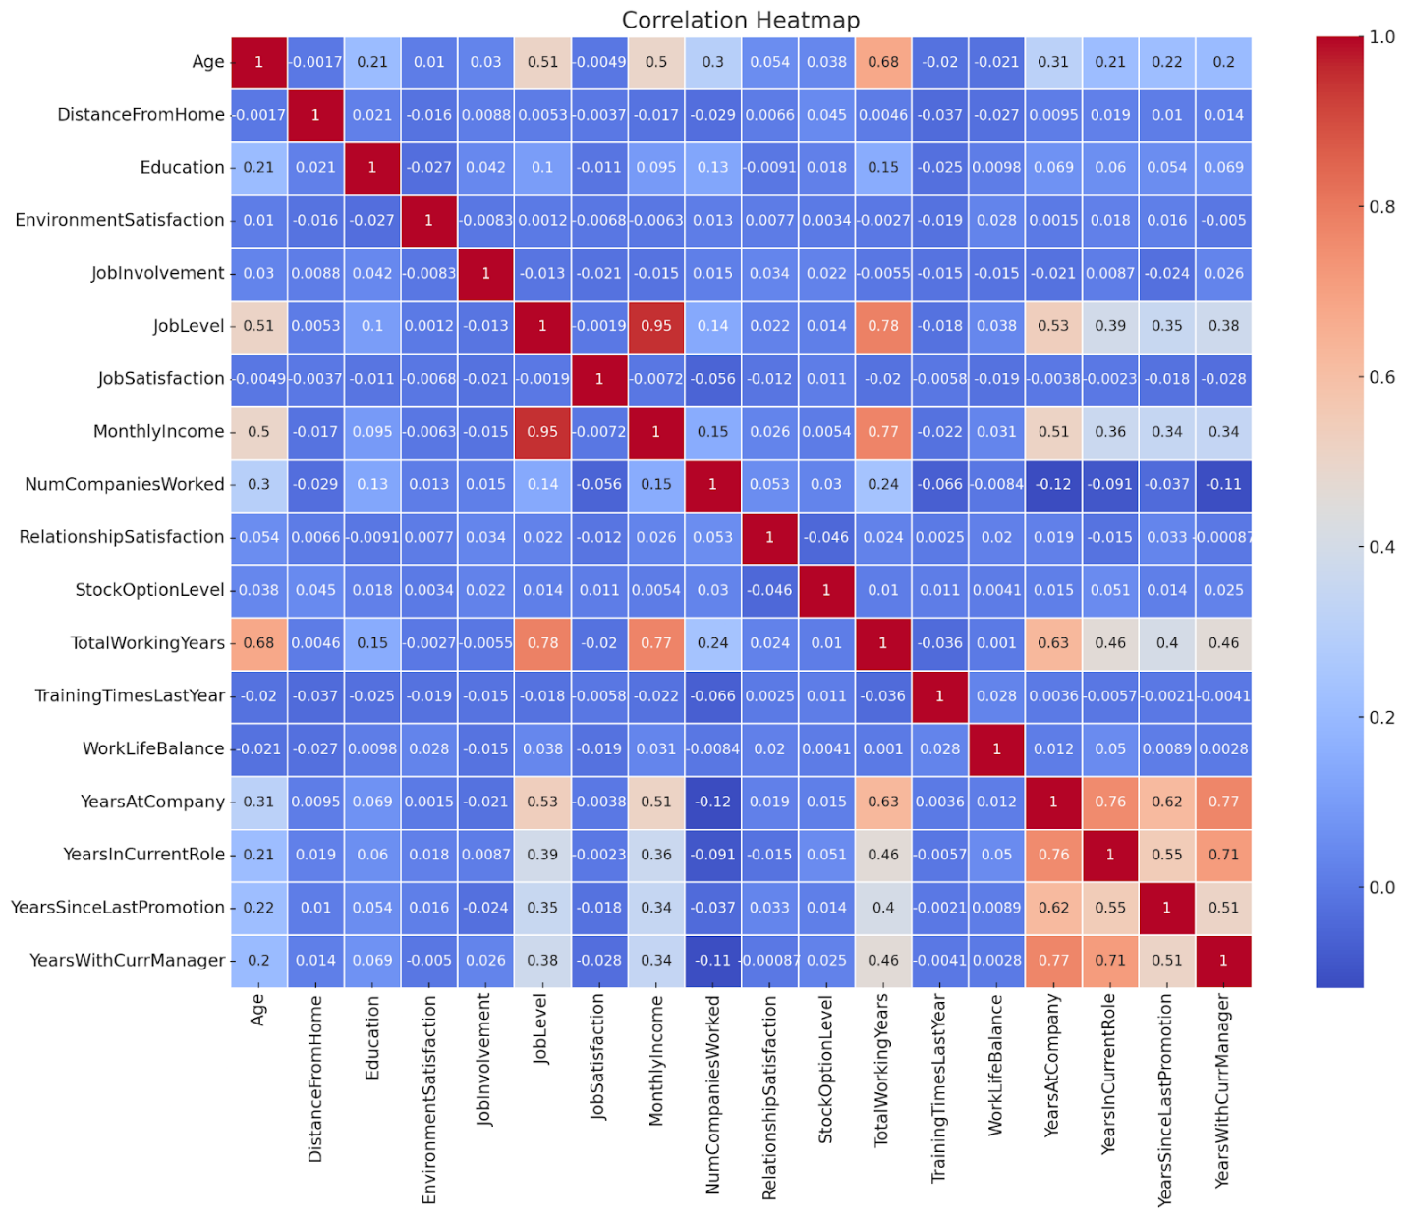

**Inferences**

* Distance From Home:There is a slight positive correlation (0.078) between attrition and the distance from home, indicating that employees living farther from the workplace might be slightly more likely to leave.

* Num Companies Worked:There is a small positive correlation (0.043) with the number of companies worked at, suggesting that employees with experience at multiple companies might have a slightly higher likelihood of attrition.
* Years With Current Manager:There is a moderate negative correlation (-0.156) with the years spent with the current manager. This suggests that employees who have been with their current manager for longer are less likely to leave.

* Years at Company:There is a moderate negative correlation (-0.134) with years at the company, indicating that employees who have been with the company longer are less likely to leave.

* Job Satisfaction:Job satisfaction has a negative correlation (-0.103) with attrition, implying that employees who are more satisfied with their jobs are less likely to leave.

* Environment Satisfaction:Environment satisfaction shows a negative correlation (-0.103) with attrition, suggesting that a more satisfying work environment is associated with lower attrition.

* Monthly Income:Monthly income has a negative correlation (-0.160) with attrition, indicating that higher-paid employees are less likely to leave.

* Job Level:Job level has a moderate negative correlation (-0.169) with attrition, suggesting that employees in higher job levels are less likely to leave.

* Total Working Years:There is a moderate negative correlation (-0.171) with total working years, indicating that employees with more work experience are less likely to leave.
* Years in Current Role:There is a moderate negative correlation (-0.161) with years in the current role, suggesting that employees who have been in their current role longer are less likely to leave.

* Age:Age has a moderate negative correlation (-0.159) with attrition, implying that older employees are less likely to leave.

These correlations provide useful insights into the factors associated with employee attrition. The most significant factors appear to be job satisfaction, work environment satisfaction, tenure with the company and current manager, and monthly income. These can inform HR strategies aimed at reducing attrition rates.

**6.5  Feature engineering**

Added new features:

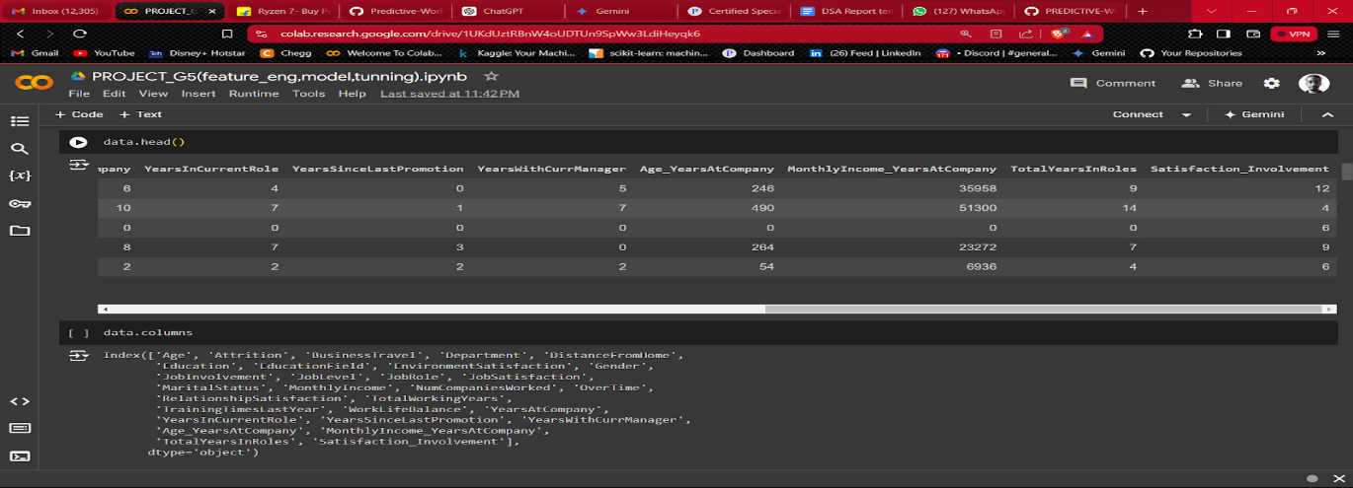

**6.5.1  Chi-square and Anova**

**Chi-square results and findings:**

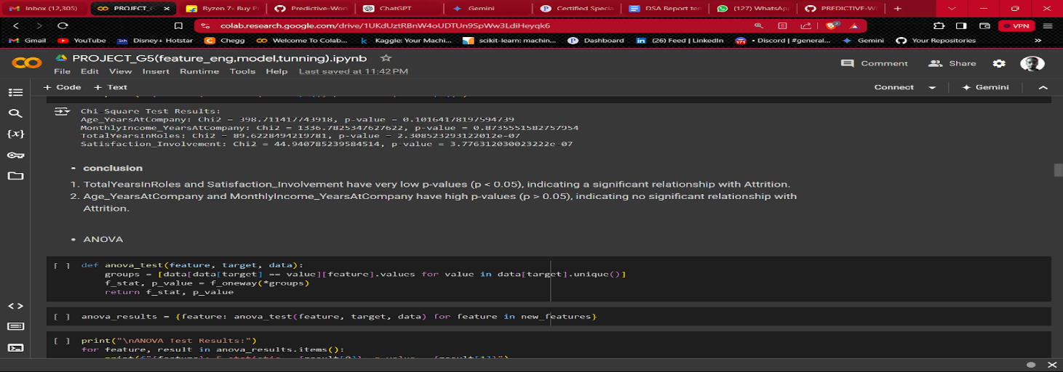

**Anova test results and findings:**

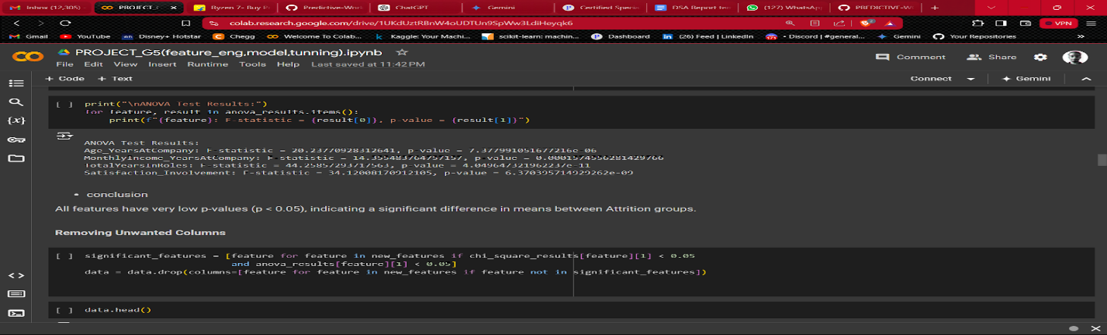

**6.6  Feature reduction**

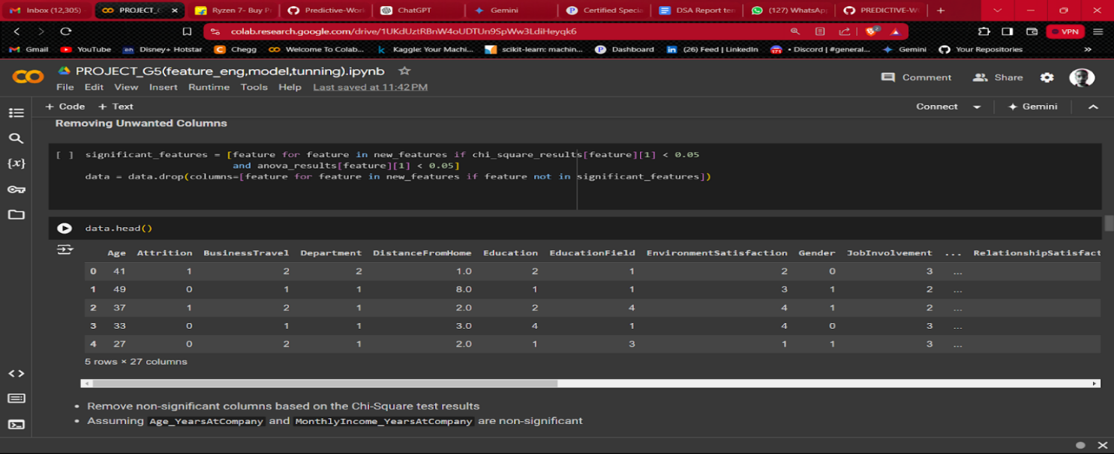

**6.7  Scaling**

Using standard scaler, all features have a uniform scale, typically with a mean of 0 and a standard deviation of 1.

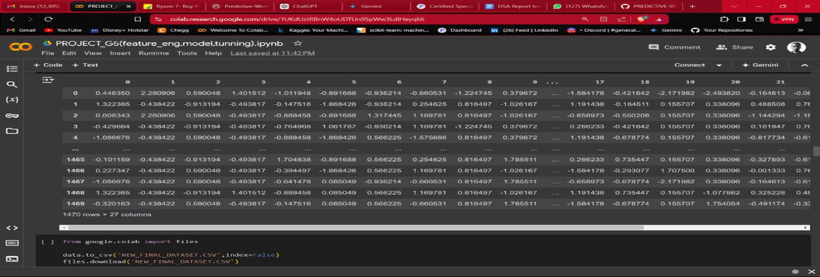

**6.8  model selection**

Model selection is the process of choosing the most appropriate machine learning model from a set of candidate models for a given dataset and problem. This process involves evaluating different models based on their performance and selecting the one that best generalizes to new, unseen data. Effective model selection is crucial for building accurate and reliable predictive models.

**6.8.1 Define the Problem:**

 It is a classification problem

**6.8.2 Import Necessary Libraries**

Before running the code, ensure you have imported all necessary libraries:

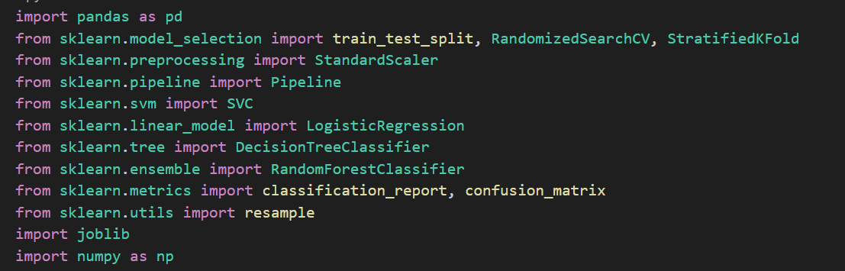

**6.8.3 Load the Dataset**

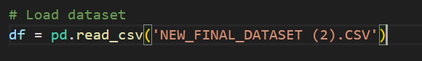

**6.8.4 Handle Class Imbalance**

Separate the majority and minority classes, then upsample the minority class to balance the dataset:

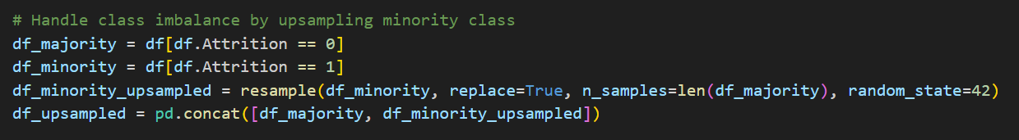

**6.8.5 Define Features and Target**

Separate the features (X) from the target variable (y):

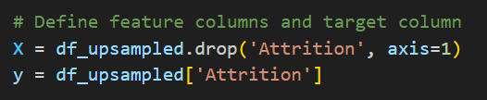

**6.8.6  Split the Data**

Split the data into training and test sets, maintaining the class distribution using stratified sampling:



**6.8.7  Define Parameter Grids for Different Models**

Define parameter grids for hyperparameter tuning for different models:

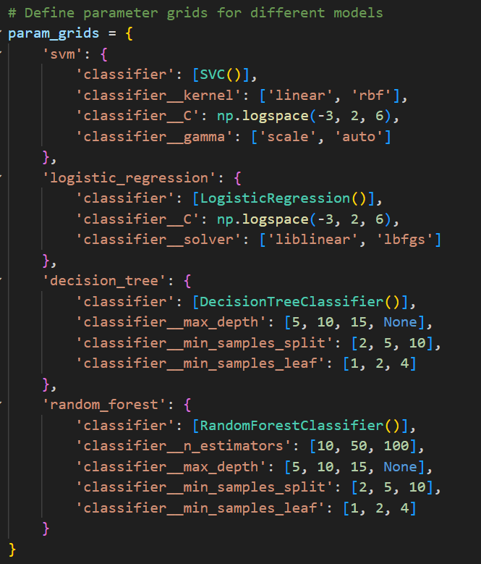

**6.8.8 Compare Models and Hyperparameter Tuning**

Iterate through each model, perform hyperparameter tuning using RandomizedSearchCV, and evaluate their performance:

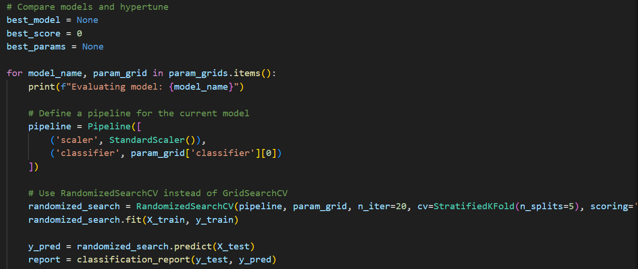

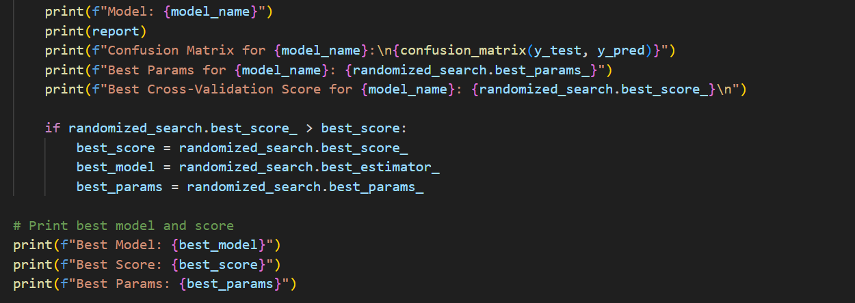

**6.8.9  Evaluate the Best Model**

Evaluate the best model on the test set: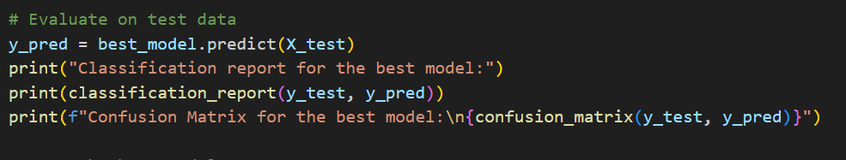

**6.8.10 Save the Best Model**

Save the best model to a file for future use: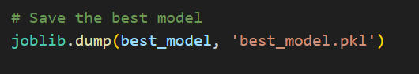

**6.9  Web application:**

A web application is a software application that runs on a web server and is accessed through a web browser over the internet or an intranet. Unlike traditional desktop applications, which are installed on a local computer, web applications are hosted on remote servers and can be accessed from any device with a web browser.

Creating a web application that predict whether an employee leaves the company or not on the basis of the independent variables considering Attrition as target.

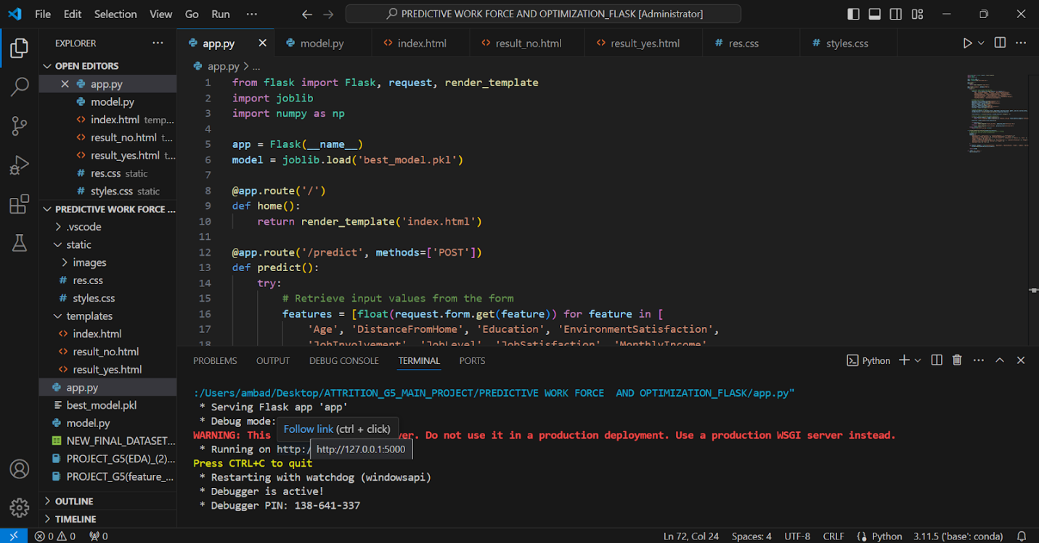

**6.9.1 Pickle file creation:**

A pickle file in Python is a file created using the pickle module, which allows you to serialize and deserialize Python objects. Serialization / pickling(The process of converting a Python object (e.g., a list, dictionary, or custom object) into a byte stream that can be saved to a file or transferred over a network) is the process of converting a Python object into a byte stream, and deserialization / unpickling (The process of converting a byte stream back into a Python object.) is the process of converting a byte stream back into a Python object.

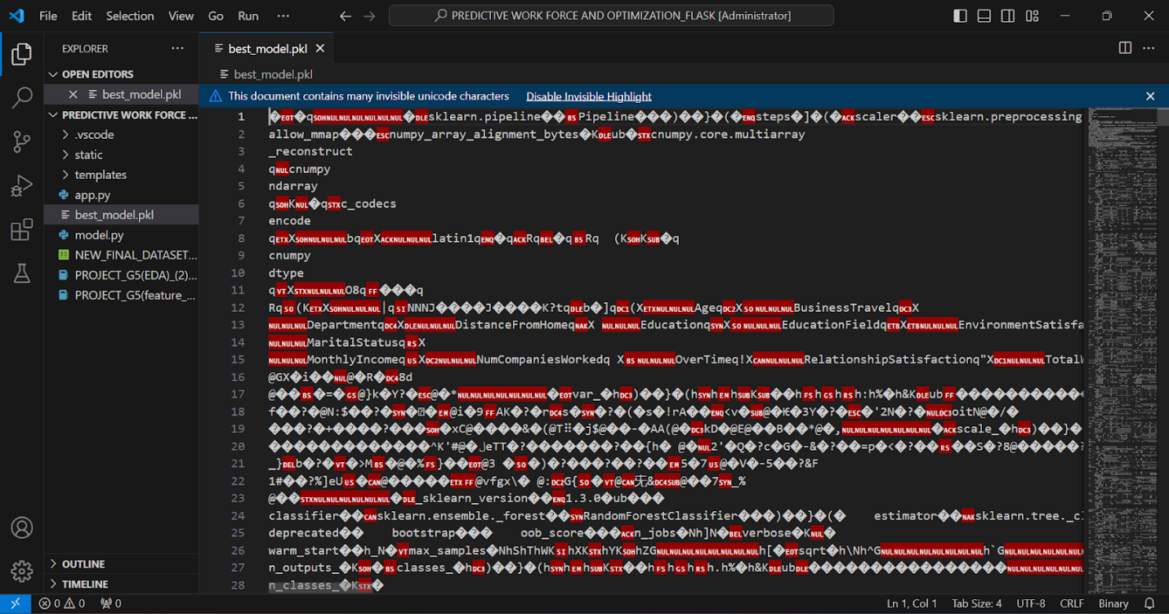

**6.9.2 HTML page:**

The Hyper Text Markup Language is the fundamental building block of a web page. It is a standard markup language used to create the structure and content of a web page.

* **index.html:**

An index.html page is the default or main webpage that is loaded when a user navigates to a website. It serves as the entry point to a website and is typically placed in the root directory of a web server. When a browser requests a directory (e.g., http://www.example.com/), the web server automatically looks for an index.html file in that directory and serves it to the user if it exists.

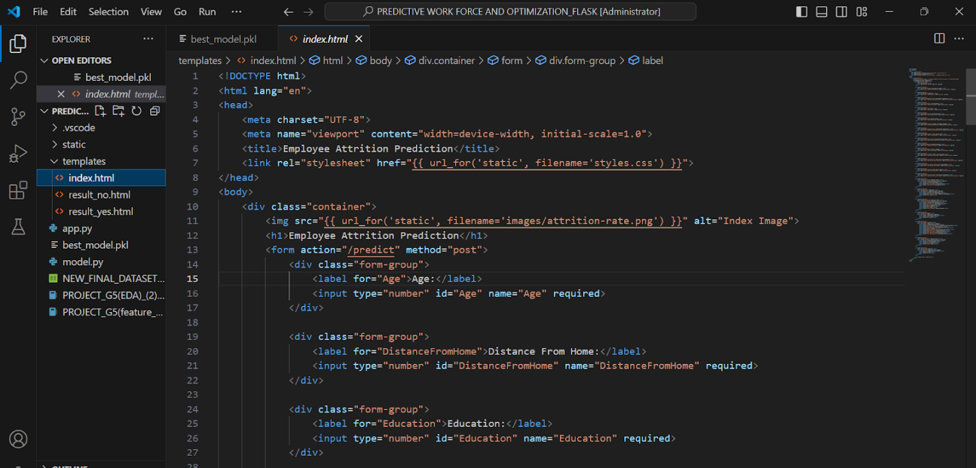

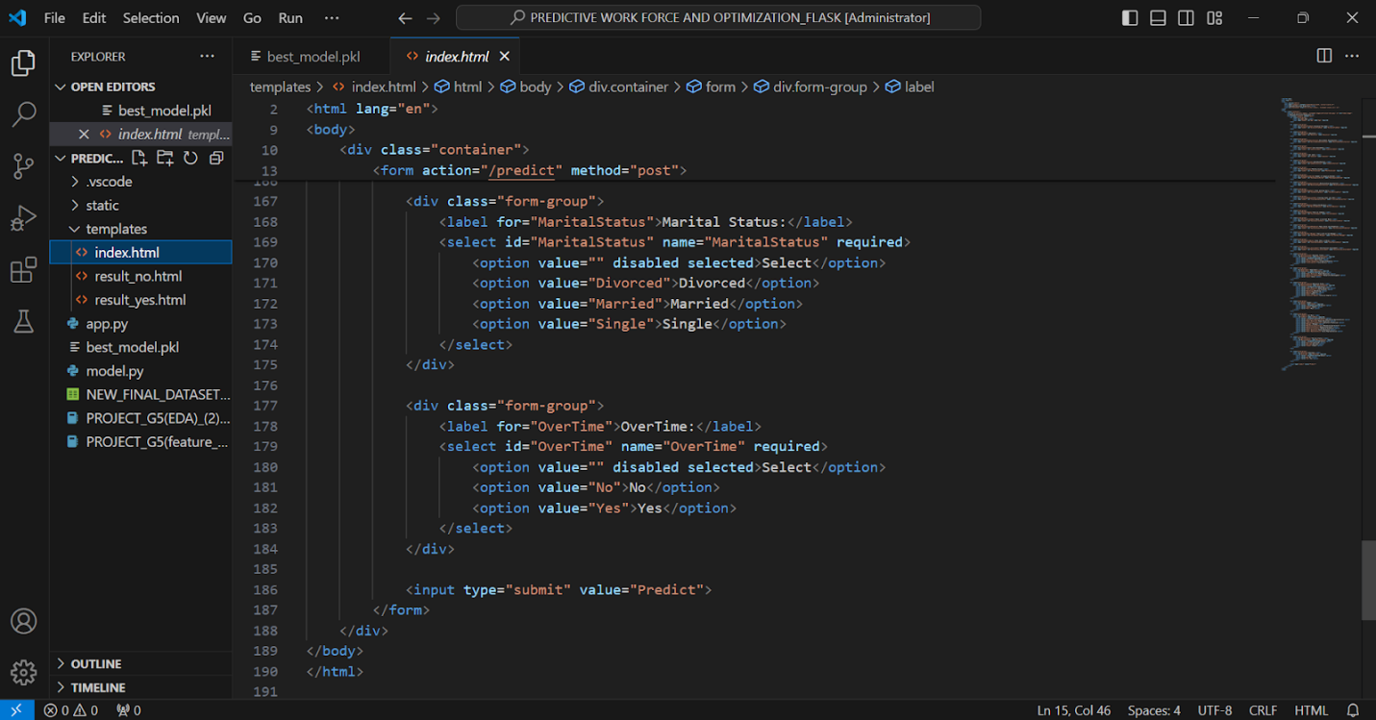

* **Result html page:**

A result.html file is typically a specific web page used to display the results of an operation or query within a web application. The contents and functionality of result.html will vary depending on the context and purpose of the web application. For example, it might show search results, quiz outcomes, form submission responses, or data processing results.

Here we have 2 result pages . one for prediction YES and one for prediction NO

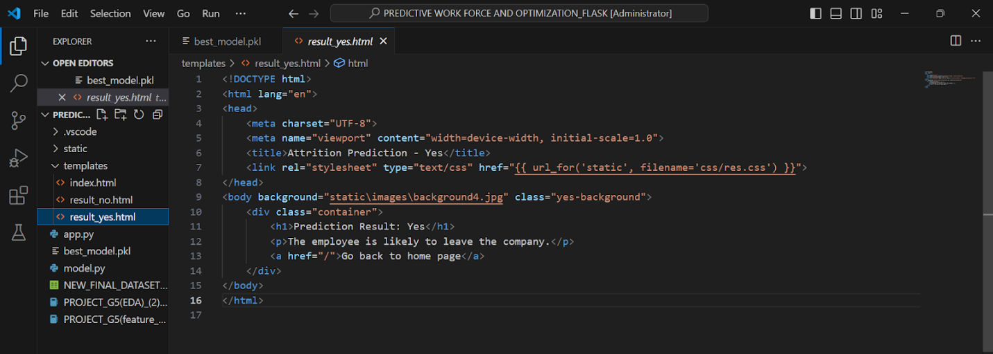

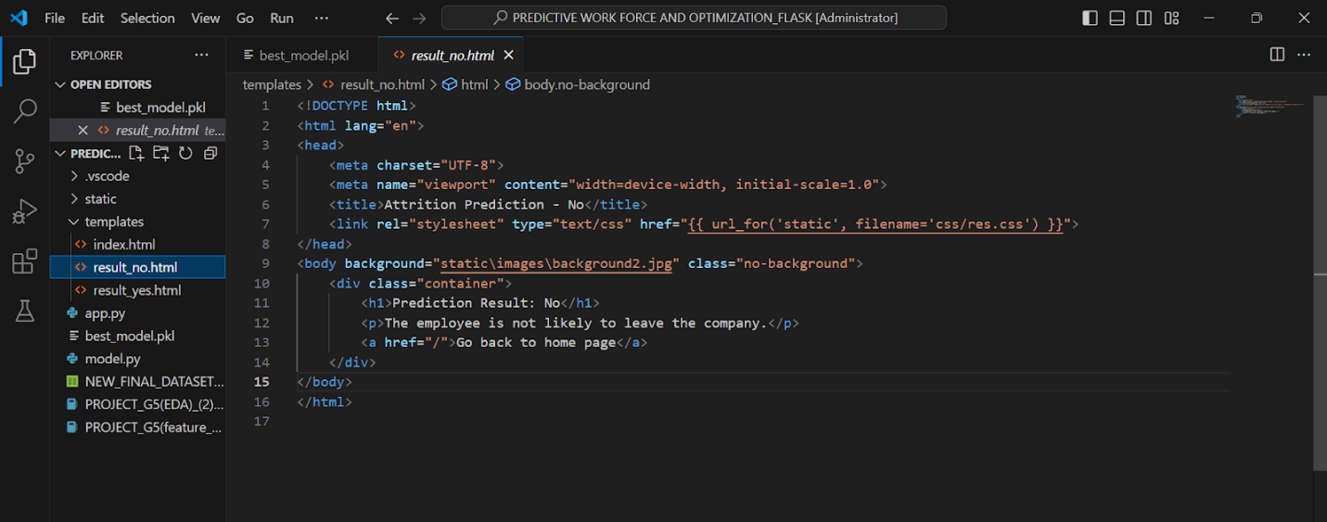

**6.9.3 CSS pages:**

Cascading style sheets is a language used to describe the presentation of a document written in HTML. CSS describes how the elements should be shown on the screen.so we have 2 css files, one for index page and one for result page.

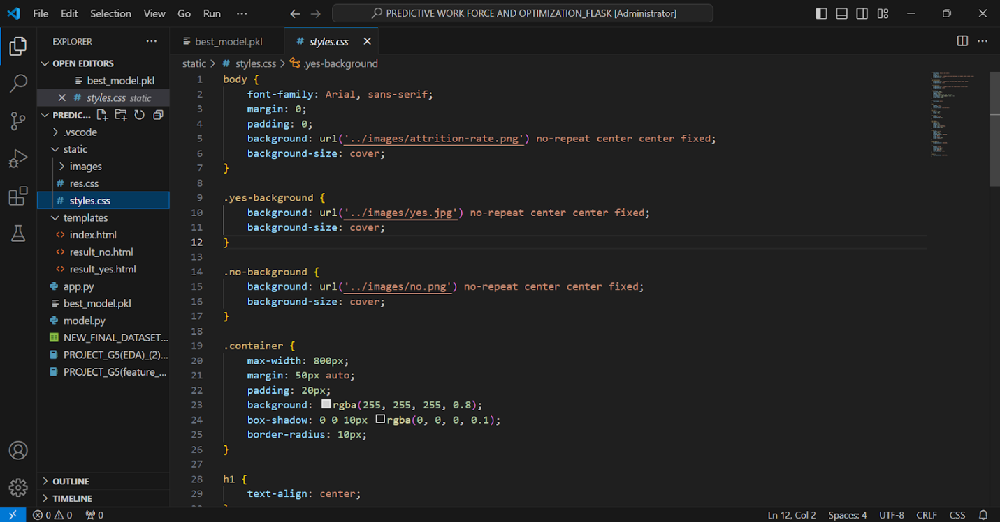

**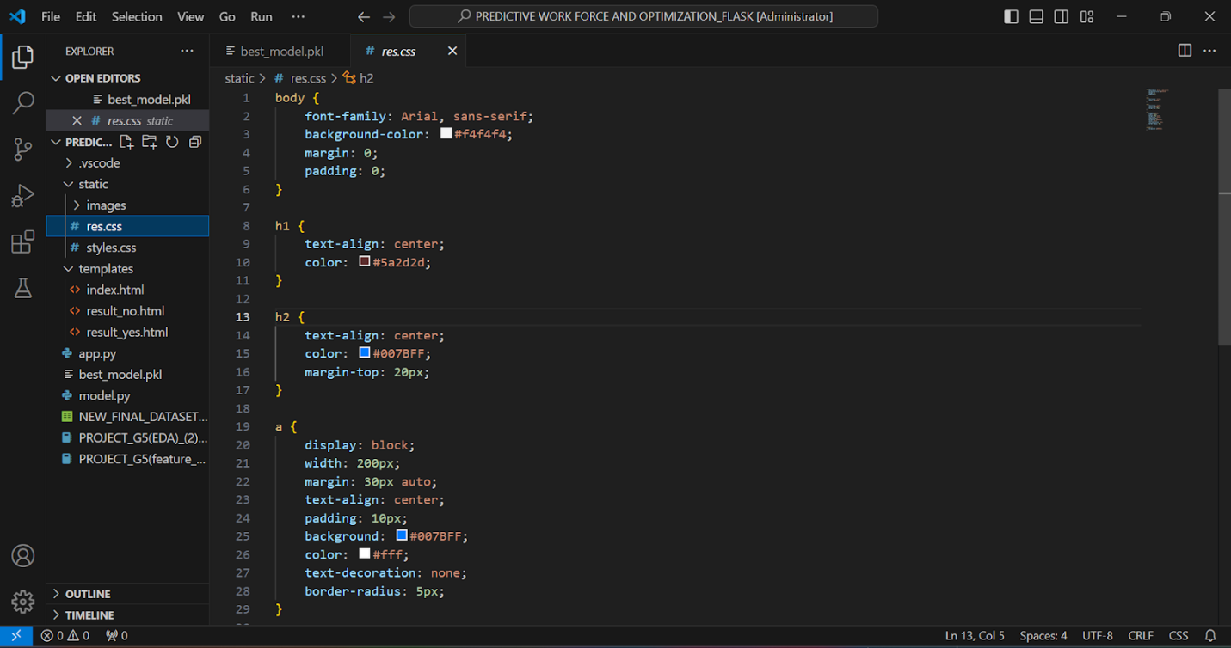 6.9.4 App.py:**

app.py is a common name for the main application file in a Python web application. This file typically contains the primary logic for setting up and running a web server, defining routes, handling requests, and rendering templates. The name app.py is a convention and can be changed to any other name, but it's often used for simplicity and clarity.

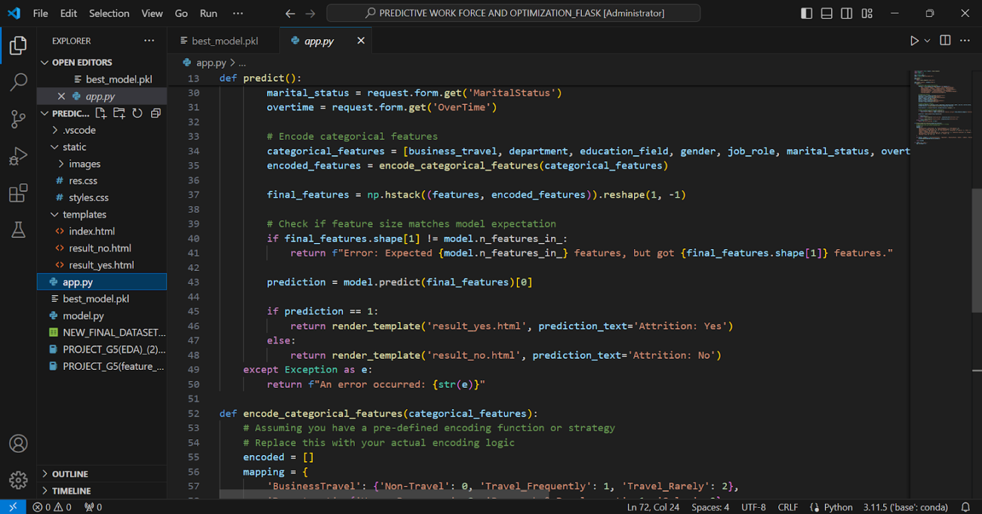

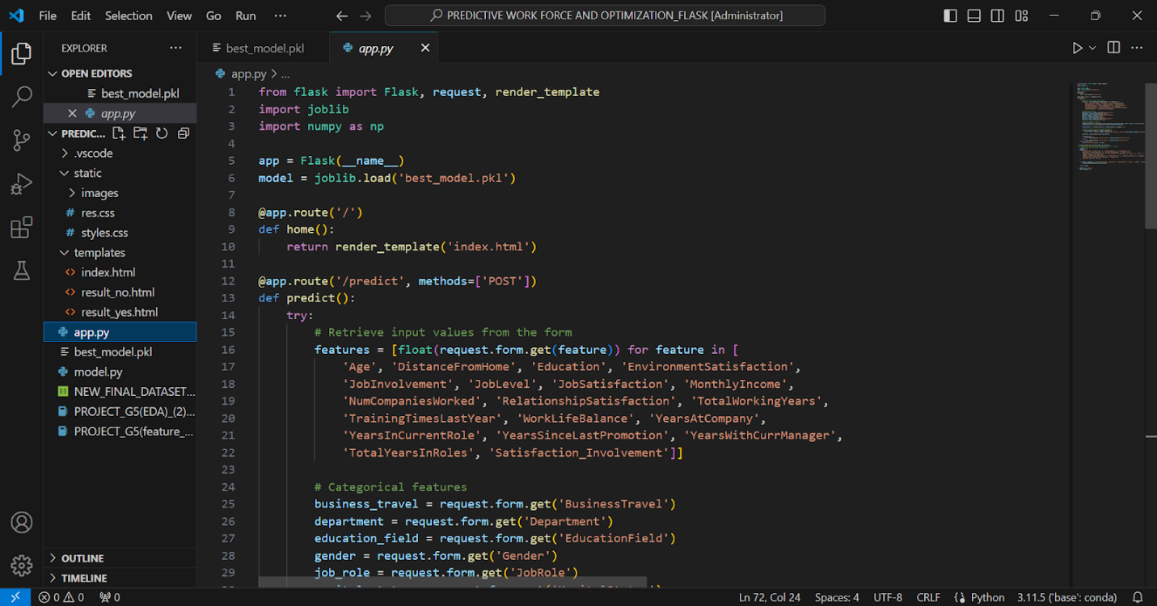

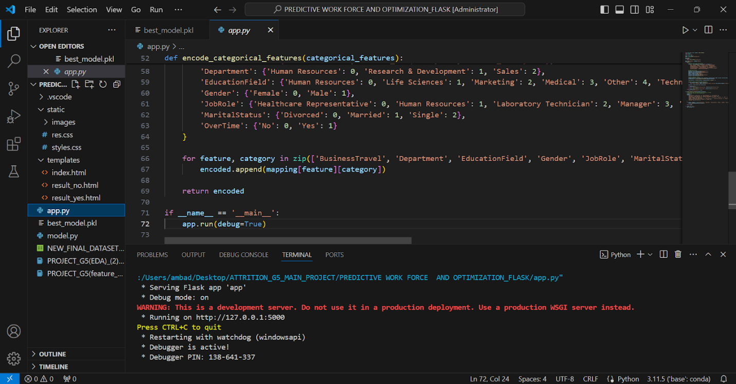

**6.10 Web hosting:**

Python anywhere is used to host our web application.

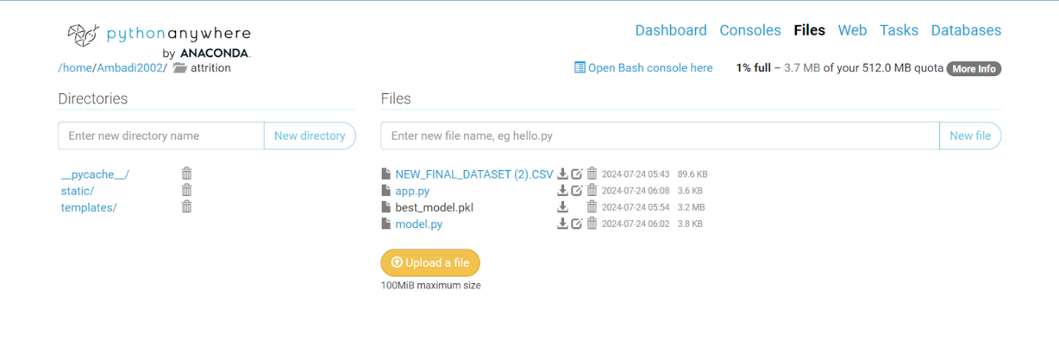

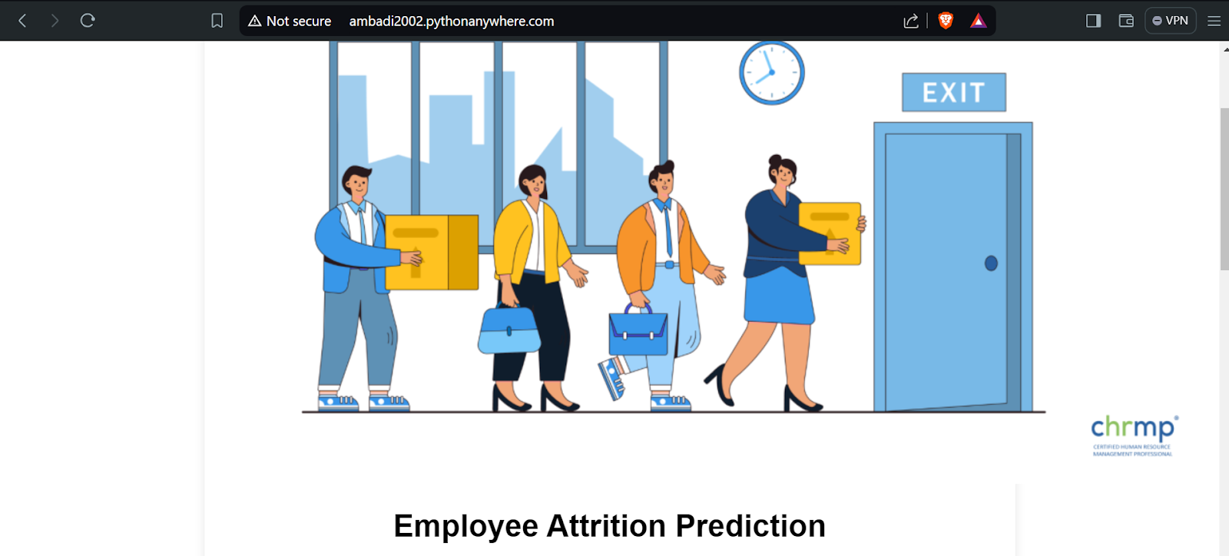

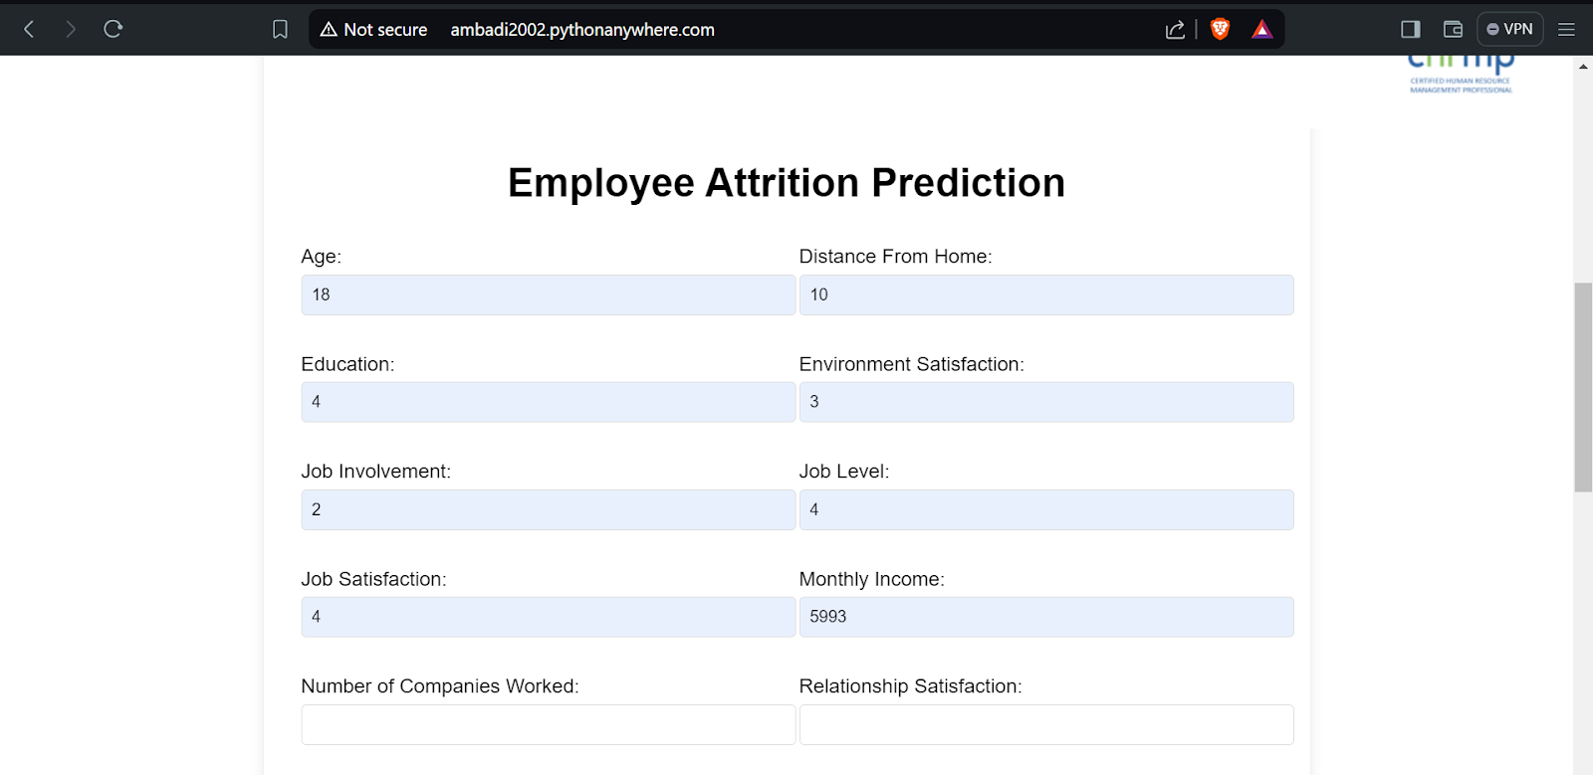

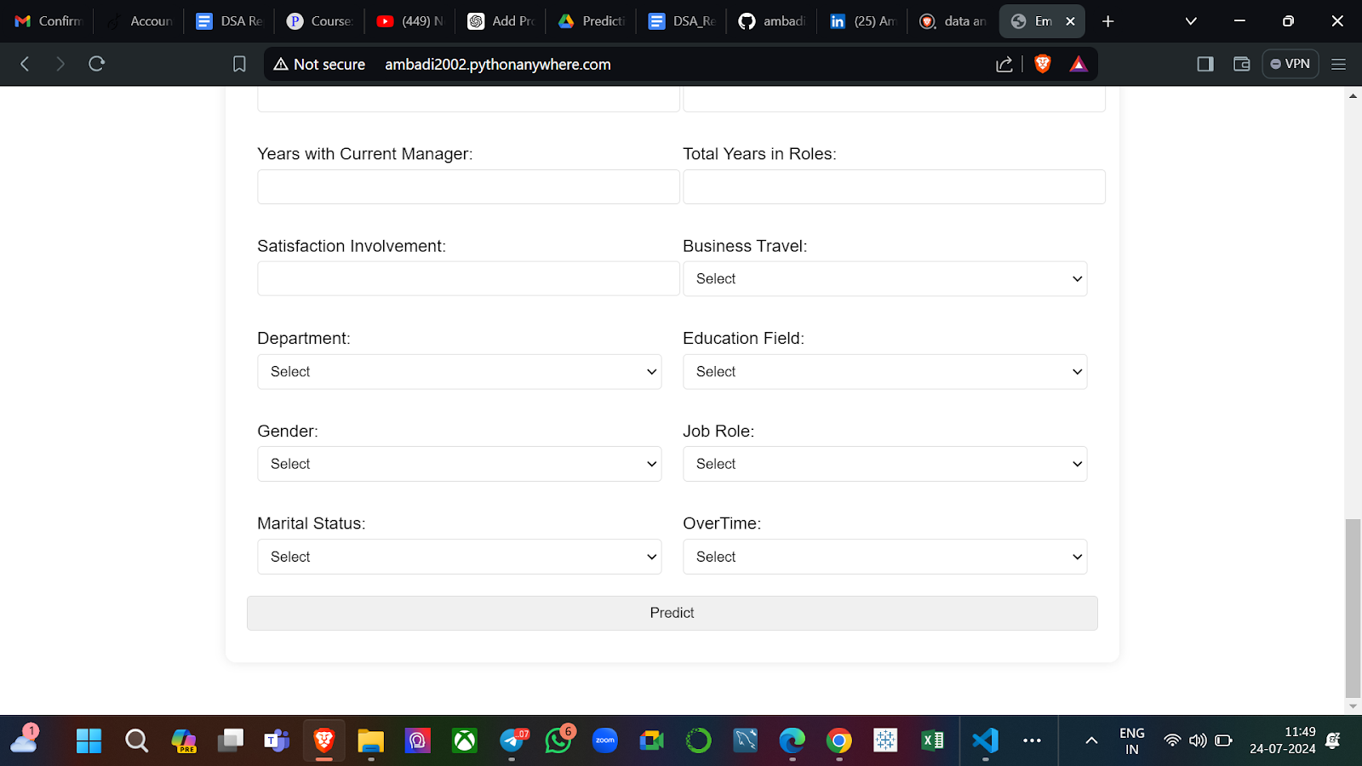





**8. Conclusion**

In this project, we developed a web application designed to predict employee attrition using a comprehensive dataset sourced from Kaggle. The project followed a systematic approach, beginning with exploratory data analysis (EDA) to understand the dataset's characteristics and identify patterns.

We conducted thorough preprocessing to address missing values, outliers, and to standardize and encode the data. This was followed by feature reduction and engineering to optimize the dataset's effectiveness for modeling. Various machine learning algorithms were implemented, including Logistic Regression, k-Nearest Neighbors (KNN), Random Forest, Decision Tree, and Support Vector Machine (SVM). Each model was evaluated and fine-tuned to enhance accuracy and performance.

The final step involved deploying the best-performing model using Flask, creating a functional web application that provides real-time predictions on employee attrition. This application is designed to assist organizations in identifying employees at risk of leaving, thereby enabling timely interventions and strategic decision-making.

Overall, the project demonstrated the power of combining data science techniques with practical application development, delivering a robust solution for predicting employee attrition.

**Reference**

#### Data Collection

The following website have been referred to obtain the input data :

<https://www.kaggle.com/datasets/pavansubhasht/ibm-hr-analytics-attrition-dataset>